Sinhgad Technical Education Society’s

**Sinhgad Institute of Business Administration and Research**

**Kondhwa (Bk.), Pune 411048**

**Subject : IT34 - Knowledge Representation and Artificial Intelligence: ML, DL** Practical

|  |  |
| --- | --- |
| Sr. No. | Assignment Question |
| 1 | Write a Python program to Find the correlation matrix. |
| 2 | Plot the correlation plot on dataset and visualize giving an overview of relationships among data on iris data. |
| 3 | Write a Python program to predict mpg (miles per gallon) for a car based on variable wt by applying simple linear regression on 'mtcars' dataset (Use Training data 80% and Testing Data 20%).  Record the performance of model in terms of MAE, MSE, RMSE and R-squared value .  Change Training data to 70% and Testing Data 30%, compare & interpret the performance of your model. |
| 4 | Write a Python program to predict mpg (miles per gallon) for a car based on variables wt, cyl & disp by applying multi-linear regression on 'mtcars' dataset (Use Training data 80% and Testing Data 20%).  Record the performance of model in terms of MAE, MSE, RMSE and R-squared value .  Remove variable disp from the feature set and check the performance again. Compare & interpret the performance of |
| 5 | Write a Python program to predict mpg (miles per gallon) for a car based on variables wt, cyl & disp by applying multi-linear regression on 'mtcars' dataset (Use Training data 80% and Testing Data 20%).  Record the performance of model in terms of MAE, MSE, RMSE and R-squared value .  Replace disp by drat variable in the feature set and check the performance again. Interpret the performance of your model. |
| 6 | Write a Python program to predict fruit (Apple or Orange) based on its size & weight by applying logistic regression on 'apples_and_oranges' dataset (Use Training data 80% and Testing Data 20%).  Evaluate the performance of the model using Accuracy Score metric, Classification Report & Confusion Matrix, AUC ROC score for the model and interpret the model performance. |
| 7 | Write a Python program to predict fruit (Apple or Orange) based on its size & weight by applying K-Nearest  Neighbour (KNN) model on 'apples_and_oranges' dataset (Use Training data 80% and Testing Data 20%).  Evaluate the performance of the model using Accuracy Score metric, Classification Report & Confusion Matrix, AUC ROC score for the model and interpret the model performance. |
| 8 | Write a Python program to predict fruit (Apple or Orange) based on its size & weight by applying Support Vector Machine (SVM) model on 'apples_and_oranges' dataset (Use Training data 80% and Testing Data 20%).  Evaluate the performance of the model using Accuracy Score metric, Classification Report & Confusion Matrix, AUC ROC score for the model and interpret the model performance. |
| 9 | Write a Python program to predict species (Setosa, Versicolor, or Viriginica) for a new iris flower based on length & width of its petals and sepals by applying logistic regression model on 'iris' dataset (Use Training data 80% and Testing Data 20%).  Evaluate the performance of the model using Accuracy Score metric, Classification Report & Confusion Matrix, AUC ROC score for the model and interpret the model performance. |
| 10 | Write a Python program to predict species (Setosa, Versicolor, or Viriginica) for a new iris flower based on length & width of its petals and sepals by applying K-Nearest Neighbour (KNN) model on 'iris' dataset (Use Training data 80% and Testing Data 20%).  Evaluate the performance of the model using Accuracy Score metric, Classification Report & Confusion Matrix, AUC ROC score for the model and interpret the model performance. |
| 11 | Write a Python program to predict species (Setosa, Versicolor, or Viriginica) for a new iris flower based on length & width of its petals and sepals by applying Support Vector Machine (SVM) model on 'iris' dataset (Use Training data 80% and Testing Data 20%).  Evaluate the performance of the model using Accuracy Score metric, Classification Report & Confusion Matrix, AUC ROC |
| 12 | score for the model and interpret the model performance.Write a Python program to predict species (Setosa, Versicolor, or Viriginica) for a new iris flower based on length & width of its petals and sepals by applying Naive Bays Classification model on 'iris' dataset (Use Training data 80% and Testing Data 20%).  Evaluate the performance of the model using Accuracy Score metric, Classification Report & Confusion Matrix, AUC ROC score for the model and interpret the model performance. |
| 13 | Write a Python program to predict species (Setosa, Versicolor, or Viriginica) for a new iris flower based on length & width of its petals and sepals by applying Decision Tree model on 'iris' dataset (Use Training data 80% and Testing Data 20%).  Evaluate the performance of the model using Accuracy Score metric, Classification Report & Confusion Matrix, AUC ROC |
| 14 | score for the model and interpret the model performance.Write a Python program to implement the K-means Algorithm on unsupervised data of a mall, that contains the basic  information (ID, age, gender, income, spending score) about the customers. Find the clusters based on the income and spending. |
| 15 | Write a Python program to implement the Agglomerative Hierarchical Clustering Algorithm on unsupervised data of a mall, that contains the basic information (ID, age, gender, income, spending score) about the customers. Find the clusters based on the income and spending. |

import numpy as np import matplotlib.pyplot as plt x = [15,20,25,30,35], y = [14.2,21.5,28.4,30.1,40.3] matrix = np.corrcoef(x, y) print(matrix) plt.scatter(x,y)

plt.title('Correlation between sales as per rupees and temperature') plt.xlabel('rupees') plt.ylabel('temp') plt.plot(matrix)

plt.show()

Output:

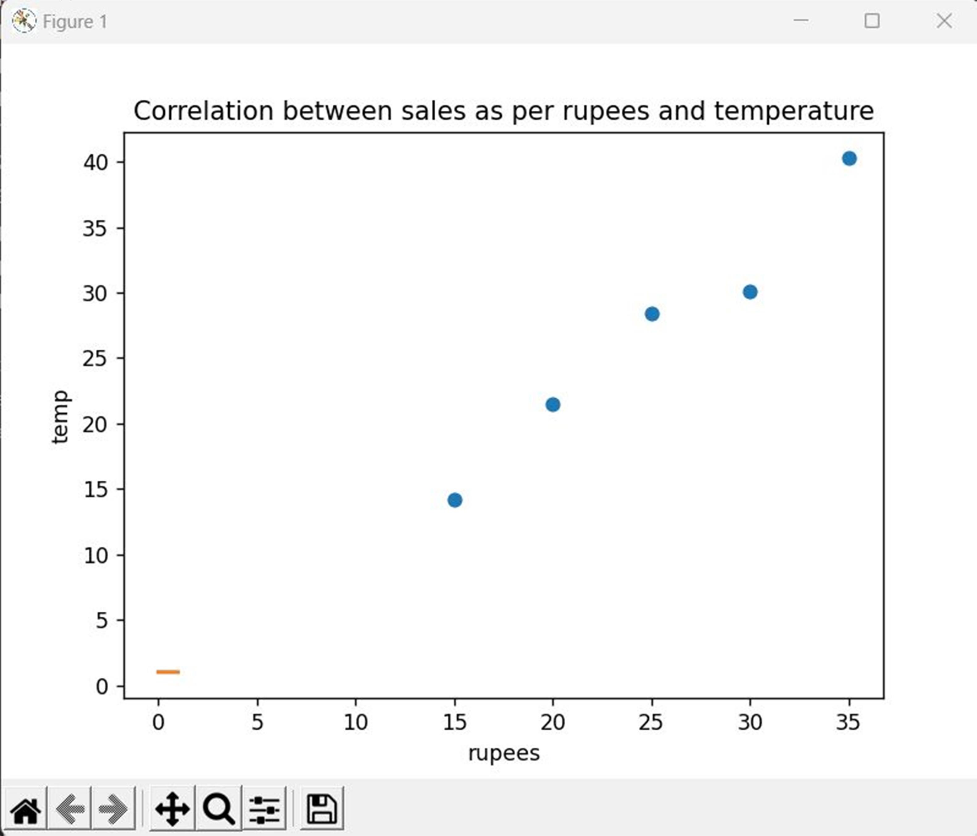

Program:

import pandas as pd import seaborn as sns import matplotlib.pyplot as plt df = pd.read_csv("Iris.csv")

rel = df.corr() print(rel) sns.pairplot(rel) plt.show()

Output:

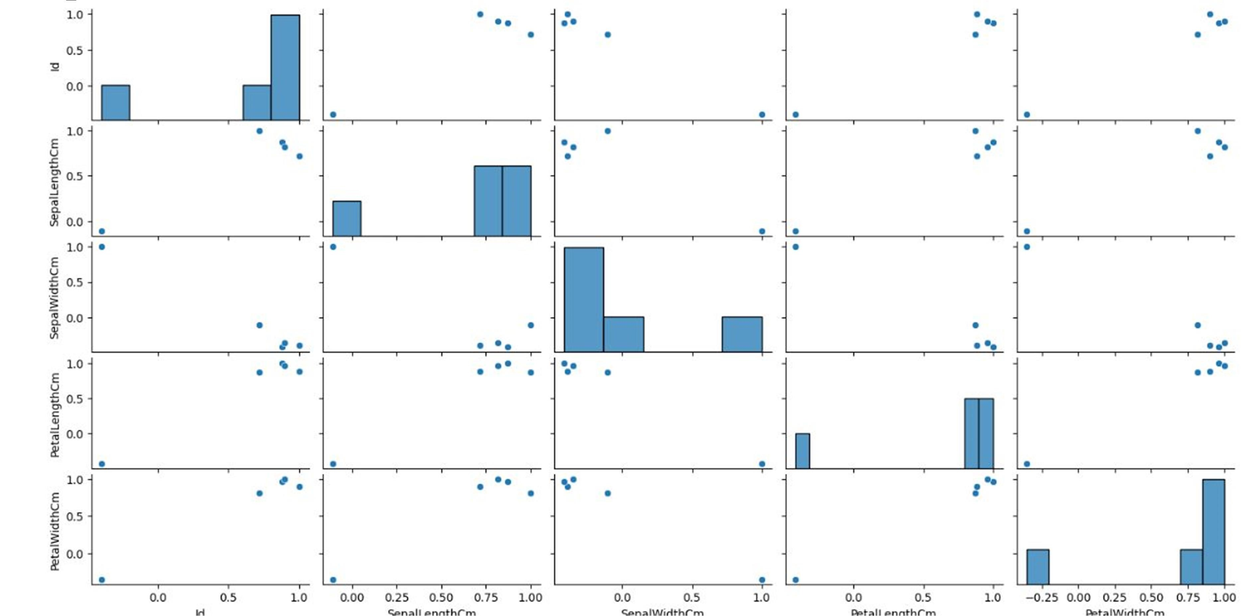

Program :

import pandas as pd

from seaborn import load_dataset import statsmodels.formula.api as sm import statsmodels.stats.multicomp as multi

iris = load_dataset("iris")

my_subset = iris[iris["species"].isin(['setosa', 'virginica'])]

subset_model = sm.ols(formula='sepal_length ~ C(species)', data=my_subset) print(subset_model.fit().summary()) my_subset.groupby("species").mean() print(my_subset.groupby("species").std())

multi_comp = multi.MultiComparison(iris['sepal_length'], iris['species']) print(multi_comp.tukeyhsd().summary())

Output:

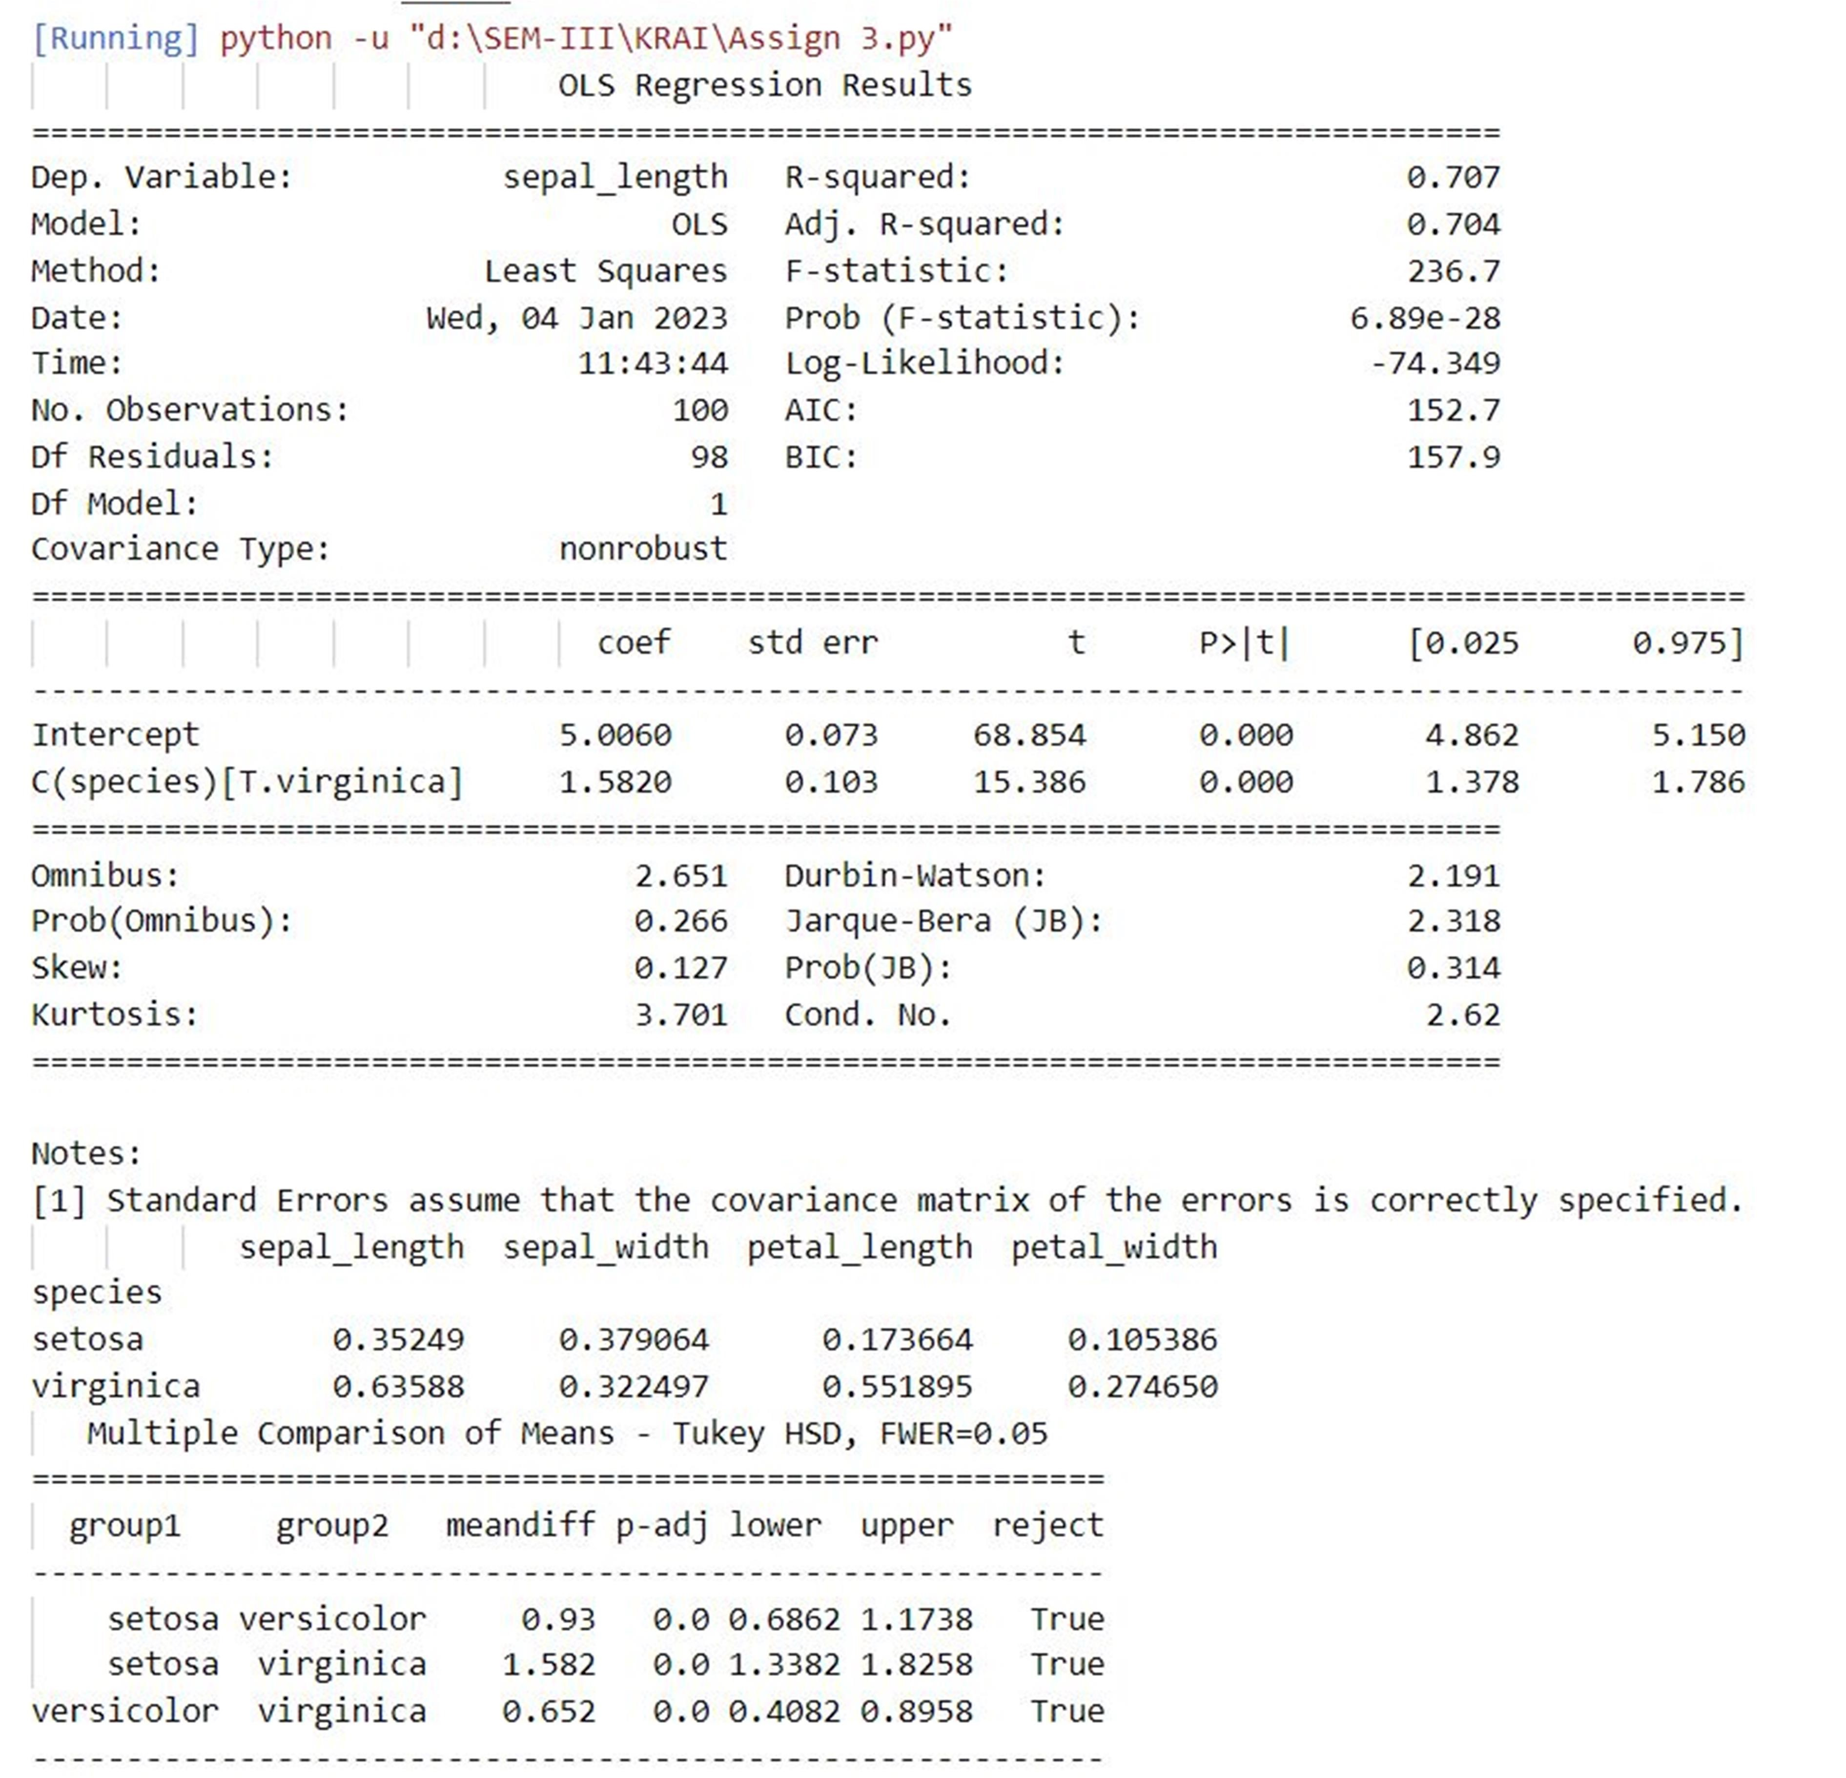

Program:

import numpy as np import matplotlib.pyplot as plt import pandas as pd

dataset = pd.read_csv('Salary_Data.csv') X = dataset.iloc[:, :-1].values y = dataset.iloc[:, 1].values

from sklearn.model_selection import train_test_split

X_train, X_test, y_train, y_test = train_test_split(X, y, test_size = 1/3, random_state = 0) from sklearn.linear_model import LinearRegression regressor = LinearRegression() regressor.fit(X_train, y_train) y_pred = regressor.predict(X_test) plt.scatter(X_train, y_train, color = 'red')

plt.plot(X_train, regressor.predict(X_train), color = 'blue') plt.scatter(X_test, y_test, color = 'red')

plt.plot(X_train, regressor.predict(X_train), color = 'blue') plt.title('Salary vs Experience (Test set)') plt.xlabel('Years of Experience')

plt.ylabel('Salary') plt.show()

Program:

import numpy as np import matplotlib.pyplot as plt import pandas as pd from sklearn.model_selection import train_test_split from sklearn.preprocessing import StandardScaler from sklearn.linear_model import LogisticRegression from sklearn.metrics import confusion_matrix from sklearn.metrics import accuracy_score from matplotlib.colors import ListedColormap dataset = pd.read_csv('DMVWrittenTests.csv') X = dataset.iloc[:, [0, 1]].values y = dataset.iloc[:, 2].values

X_train, X_test, y_train, y_test = train_test_split(X, y,test_size = 0.25, random_state = 0) sc = StandardScaler()

X_train = sc.fit_transform(X_train) X_test = sc.transform(X_test) classifier = LogisticRegression() classifier.fit(X_train, y_train) y_pred = classifier.predict(X_test) cm = confusion_matrix(y_test, y_pred) print ("Accuracy : ", accuracy_score(y_test, y_pred))

df = pd.DataFrame({'Real Values':y_test, 'PredictedValues':y_pred})

X_set, y_set = X_test, y_test

X1, X2 = np.meshgrid(np.arange(start = X_set[:, 0].min() - 1,stop = X_set[:, 0].max() + 1, step = 0.01),np.arange(start = X_set[:, 1].min() - 1, stop = X_set[:, 1].max() + 1, step = 0.01))

plt.contourf(X1, X2, classifier.predict(np.array([X1.ravel(),X2.ravel()]).T).reshape(X1.shape), alpha = 0.75, cmap = ListedColormap(('orange',

'green')))

plt.xlim(X1.min(), X1.max()) plt.ylim(X2.min(), X2.max()) for i, j in enumerate(np.unique(y_set)):

plt.scatter(X_set[y_set == j, 0], X_set[y_set == j, 1],c = ListedColormap(('blue', 'yellow'))(i), label =j) plt.title('Logistic Regression') plt.xlabel('Logistic_Test_1') plt.ylabel('Logistic_Test_2')

plt.legend() plt.show()

Output:

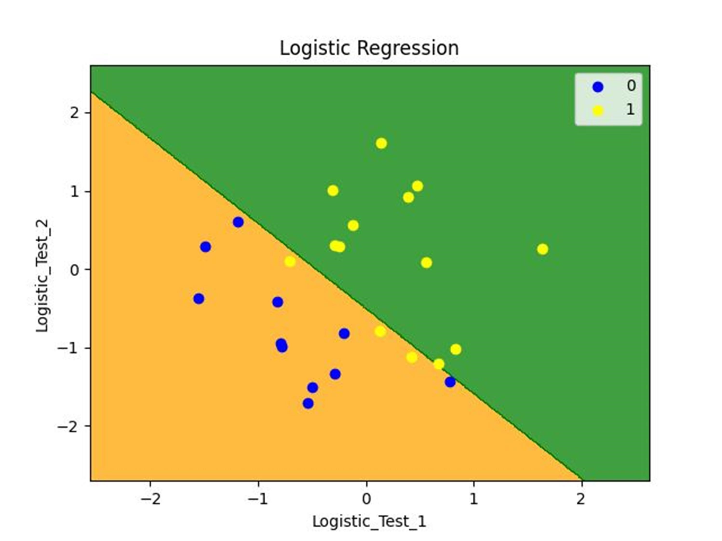

Program:

from numpy import unique from numpy import where from sklearn.datasets import make_classification from sklearn.cluster import KMeans from matplotlib import pyplot

# define dataset

X, _ = make_classification(n_samples=1000, n_features=2, n_informative=2, n_redundant=0, n_clusters_per_class=1, random_state=4)

# define the model

model = KMeans(n_clusters=2)

# fit the model model.fit(X)

# assign a cluster to each example yhat = model.predict(X) # retrieve unique clusters clusters = unique(yhat)

# create scatter plot for samples from each cluster for cluster in clusters:

# get row indexes for samples with this cluster row_ix = where(yhat == cluster) # create scatter of these samples

pyplot.scatter(X[row_ix, 0], X[row_ix, 1])

# show the plot pyplot.show()

Output:

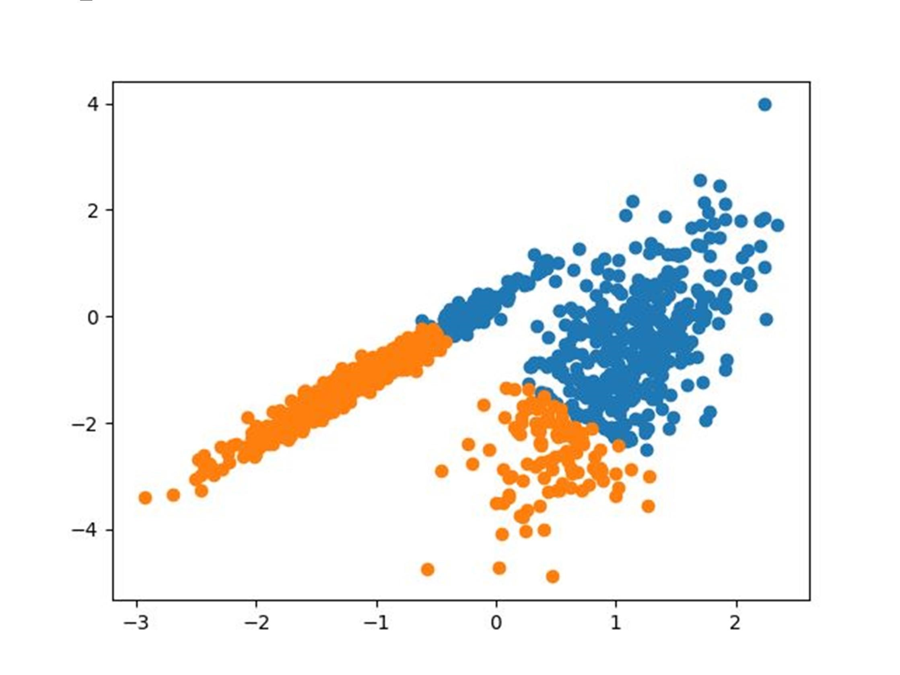

Program:

from numpy import unique from numpy import where from sklearn.datasets import make_classification from sklearn.cluster import AgglomerativeClustering from matplotlib import pyplot

# define dataset

X, _ = make_classification(n_samples=1000, n_features=2, n_informative=2, n_redundant=0, n_clusters_per_class=1, random_state=4)

# define the model

model = AgglomerativeClustering(n_clusters=2)

# fit model and predict clusters yhat = model.fit_predict(X) # retrieve unique clusters clusters = unique(yhat)

# create scatter plot for samples from each cluster for cluster in clusters:

# get row indexes for samples with this cluster row_ix = where(yhat == cluster) # create scatter of these samples

pyplot.scatter(X[row_ix, 0], X[row_ix, 1])

# show the plot pyplot.show()

Output:

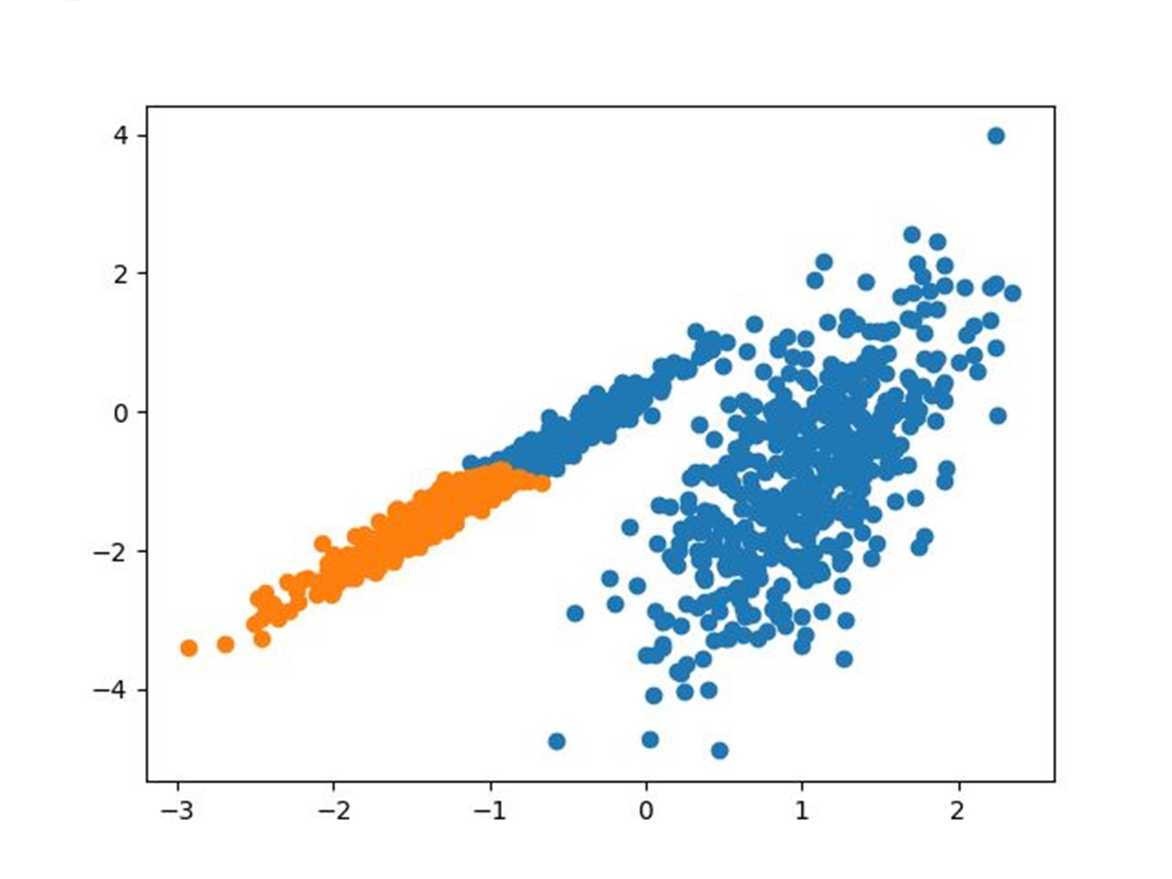

Program:

import pandas as pd import numpy as np import matplotlib.pyplot as plt from sklearn import datasets import scipy.cluster.hierarchy as sc import matplotlib.pyplot as plt from sklearn.cluster import AgglomerativeClustering

# Import iris data iris = datasets.load_iris() iris_data = pd.DataFrame(iris.data) iris_data.columns = iris.feature_names iris_data['flower_type'] = iris.target iris_data.head() iris_X = iris_data.iloc[:, [0, 1, 2,3]].values iris_Y = iris_data.iloc[:,4].values """plt.figure(figsize=(10, 7)) plt.scatter(iris_X[iris_Y == 0, 0], iris_X[iris_Y == 0, 1], s=100, c='blue', label='Type 1') plt.scatter(iris_X[iris_Y == 1, 0], iris_X[iris_Y == 1, 1], s=100, c='yellow', label='Type 2') plt.scatter(iris_X[iris_Y == 2, 0], iris_X[iris_Y == 2, 1], s=100, c='green', label='Type 3') plt.legend() plt.show()""" # Plot dendrogram plt.figure(figsize=(20, 7)) plt.title("Dendrograms") # Create dendrogram

sc.dendrogram(sc.linkage(iris_X, method='ward'))

plt.title('Dendrogram') plt.xlabel('Sample index') plt.ylabel('Euclidean distance') cluster = AgglomerativeClustering( n_clusters=3, affinity='euclidean', linkage='ward') cluster.fit(iris_X) labels = cluster.labels_ print(labels) plt.figure(figsize=(10, 7)) plt.scatter(iris_X[labels == 0, 0], iris_X[labels == 0, 1], s = 100, c = 'blue', label = 'Type 1') plt.scatter(iris_X[labels == 1, 0], iris_X[labels == 1, 1], s = 100, c = 'yellow', label = 'Type 2') plt.scatter(iris_X[labels == 2, 0], iris_X[labels == 2, 1], s = 100, c = 'green', label = 'Type 3') plt.legend()

plt.show()

Output:

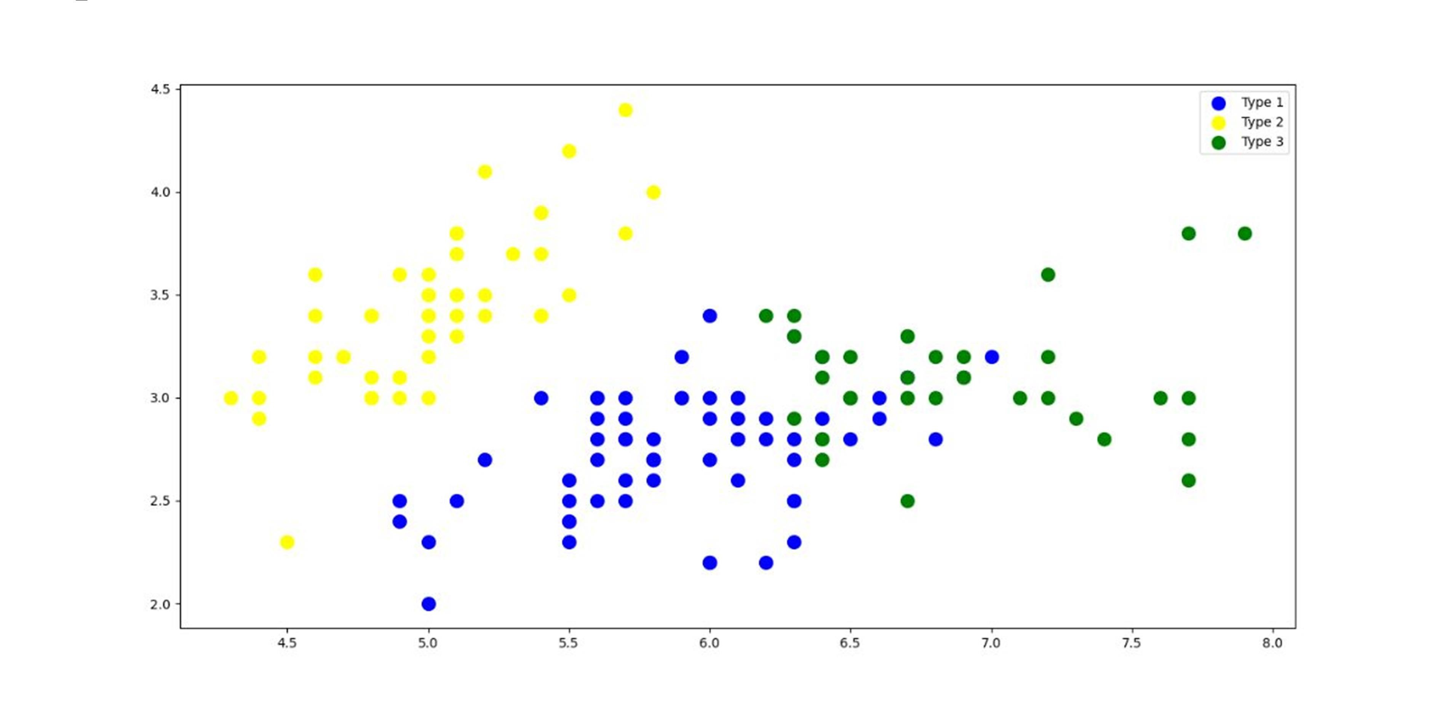

Program:

import pandas as pd import matplotlib.pyplot as plt from efficient_apriori import apriori

df =pd.read_csv('Market_Basket_Optimisation.csv', encoding='utf-8', header=None) txns=df.values.reshape(-1).tolist() df_list=pd.DataFrame(txns) df_list['Count']=1 txns=df.values.reshape(-1).tolist()

df_list=df_list.groupby(by=[0],as_index=False).count().sort_values(by=['Count'],ascending= True) # count

df_list['Percentage'] = (df_list['Count'] /df_list['Count'].sum()) # percentage df_list=df_list.rename(columns={0 : 'Item'}) df_list

plt.figure(figsize=(16,20), dpi=40) plt.ylabel('Item Name') plt.xlabel('Count')

plt.barh(df_list['Item'], width=df_list['Count'], color='r',height=0.9) plt.margins(0.01) plt.show()

Output:

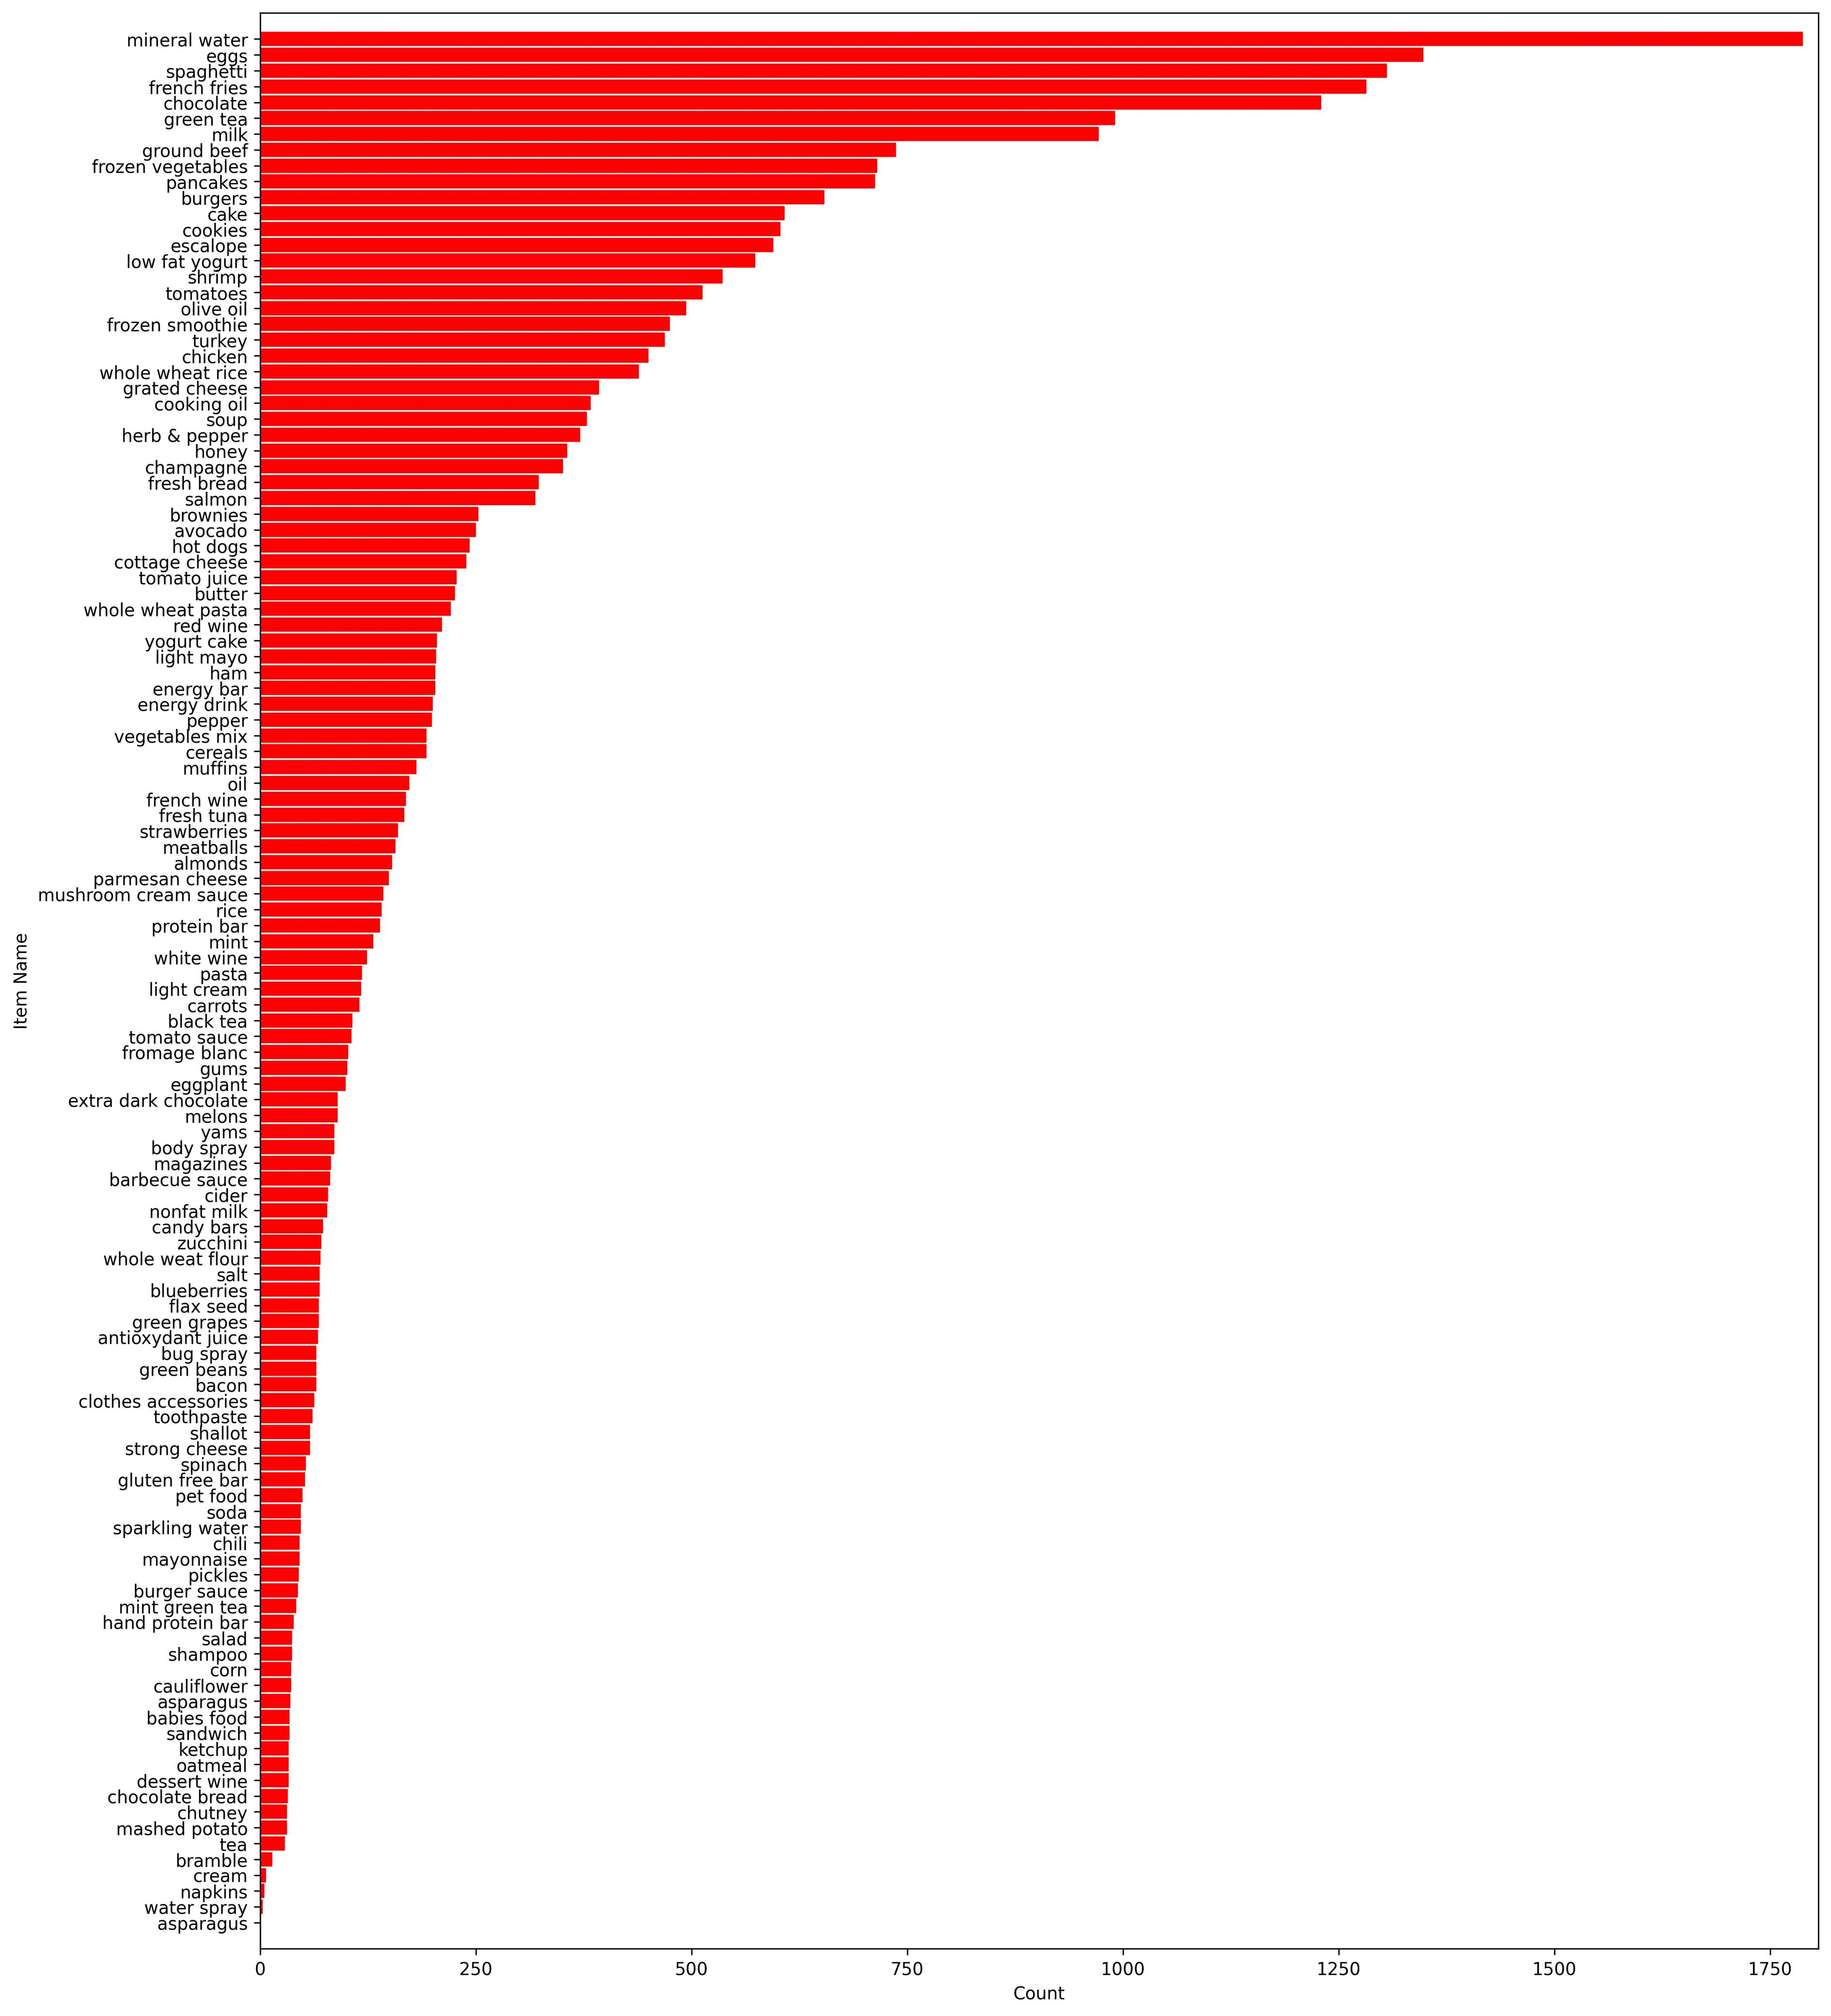

Program:

import pandas as pd import numpy as np import matplotlib.pyplot as plt import seaborn as sns from sklearn.preprocessing import LabelEncoder#for train test splitting from sklearn.model_selection import train_test_split#for decision tree object from sklearn.tree import DecisionTreeClassifier#for checking testing results from sklearn.metrics import classification_report, confusion_matrix#for visualizing tree from sklearn.tree import plot_tree df = sns.load_dataset('iris') df.head() df.info() df.shape df.isnull().any() sns.pairplot(data=df, hue = 'species') sns.heatmap(df.corr()) target = df['species'] df1 = df.copy() df1 = df1.drop('species', axis =1) X = df1 print(target) le = LabelEncoder() target = le.fit_transform(target) print(target) y = target

X_train, X_test, y_train, y_test = train_test_split(X , y, test_size = 0.2, random_state = 42) print("Training split input- ", X_train.shape) print("Testing split input- ", X_test.shape) dtree=DecisionTreeClassifier() dtree.fit(X_train,y_train) print('Decision Tree Classifier Created') y_pred = dtree.predict(X_test) print("Classification report - \n", classification_report(y_test,y_pred))

cm = confusion_matrix(y_test, y_pred)

plt.figure(figsize=(5,5)) sns.heatmap(data=cm,linewidths=.5, annot=True,square = True, cmap = 'Blues') plt.ylabel('Actual label') plt.xlabel('Predicted label') all_sample_title = 'Accuracy Score: {0}'.format(dtree.score(X_test, y_test)) plt.title(all_sample_title, size = 15)

dec_tree = plot_tree(decision_tree=dtree, feature_names = df1.columns,

class_names =["setosa", "vercicolor", "verginica"] , filled = True , precision = 4, rounded = True) plt.show()

Output:

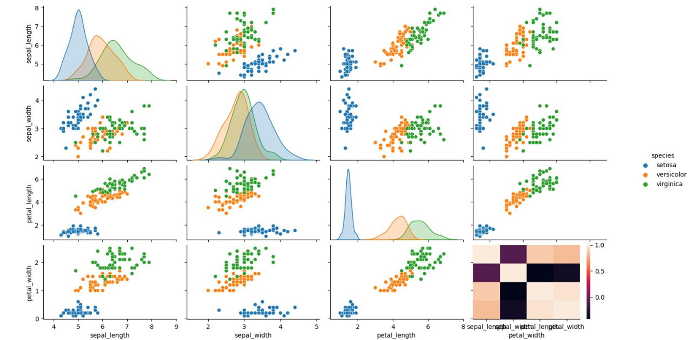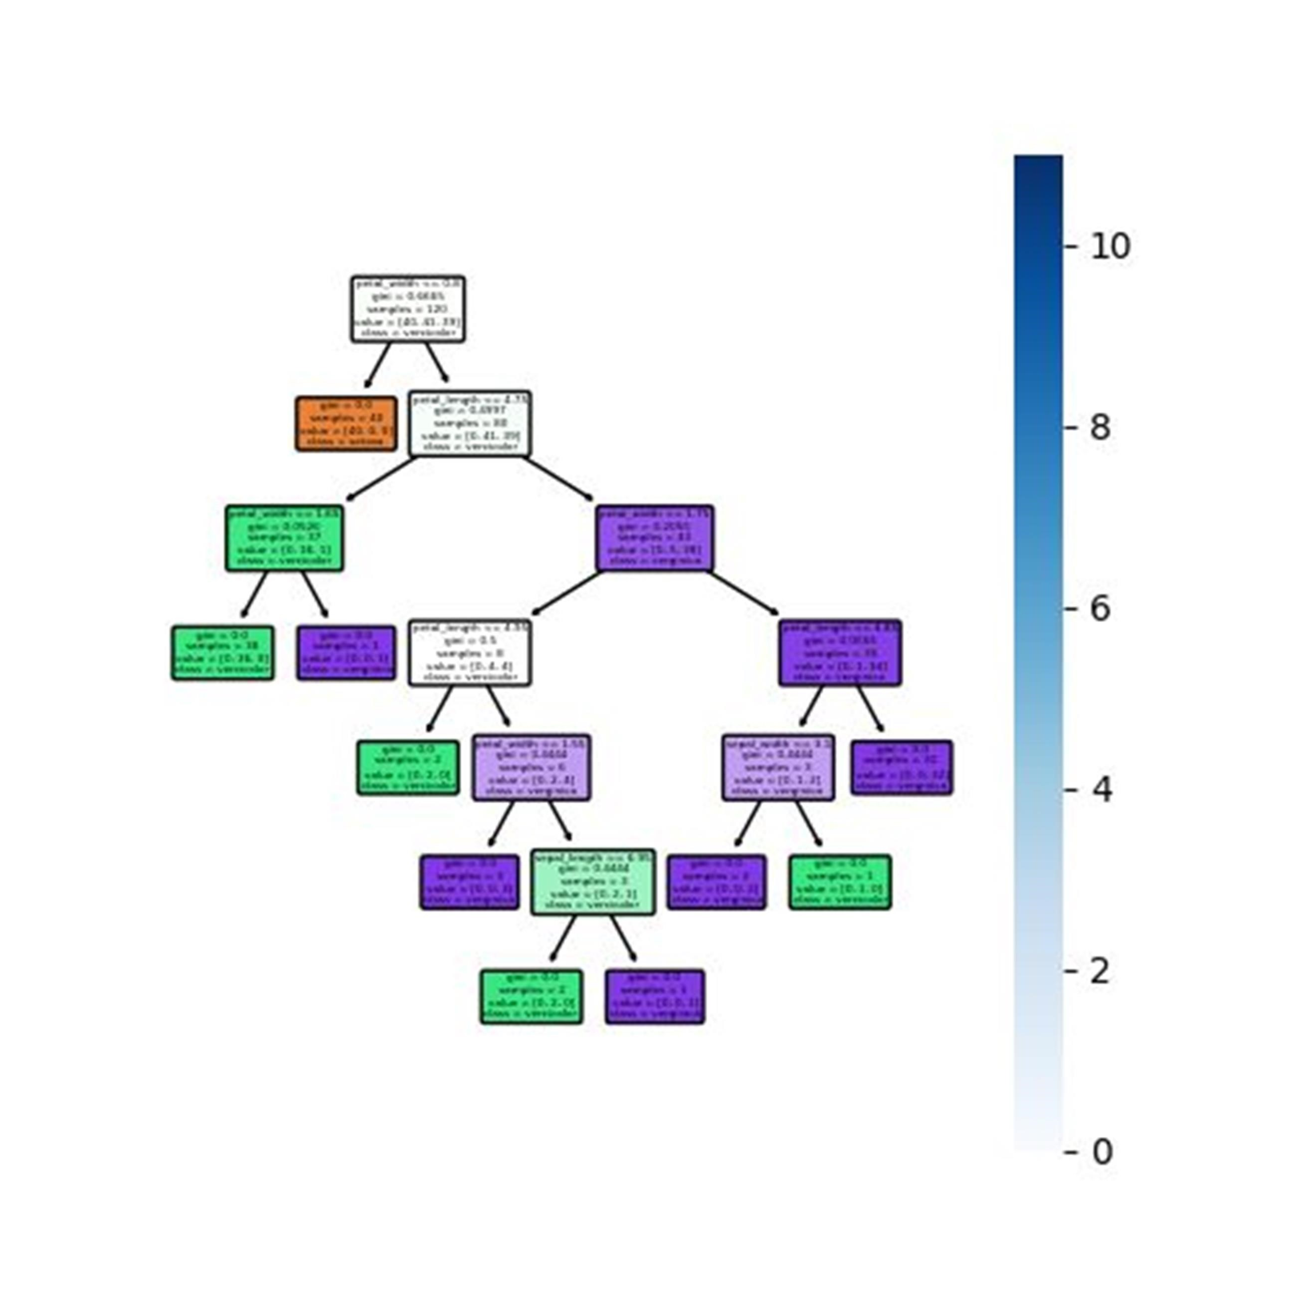

Program:

from sklearn.datasets import load_iris

iris = load_iris()

# store the feature matrix (X) and response vector (y) X = iris.data y = iris.target

# splitting X and y into training and testing sets from sklearn.model_selection import train_test_split

X_train, X_test, y_train, y_test = train_test_split(X, y, test_size=0.3, random_state=3)

# training the model on training set from sklearn.naive_bayes import GaussianNB gnb = GaussianNB() gnb.fit(X_train, y_train)

# making predictions on the testing set y_pred = gnb.predict(X_test)

# comparing actual response values (y_test) with predicted response values (y_pred) from sklearn import metrics

print("Gaussian Naive Bayes model accuracy(in %):", metrics.accuracy_score(y_test, y_pred)*100)

Output:



Program:

import pandas as pd

from sklearn.model_selection import train_test_split

from sklearn.svm import SVC dataset_url = "Fish.csv" fish = pd.read_csv(dataset_url)

fish

fish = pd.read_csv(dataset_url)

X = fish.drop(['Species'], axis = 'columns') y = fish.Species

X_train, X_test, y_train, y_test = train_test_split(X, y, test_size= 0.2)

model = SVC(kernel = 'linear', C = 1) model.fit(X_train, y_train) svm_pred = model.predict(X_test) accuracy = model.score(X_test, y_test) print("SVC Clacification: {0}".format(accuracy))

OutPut:

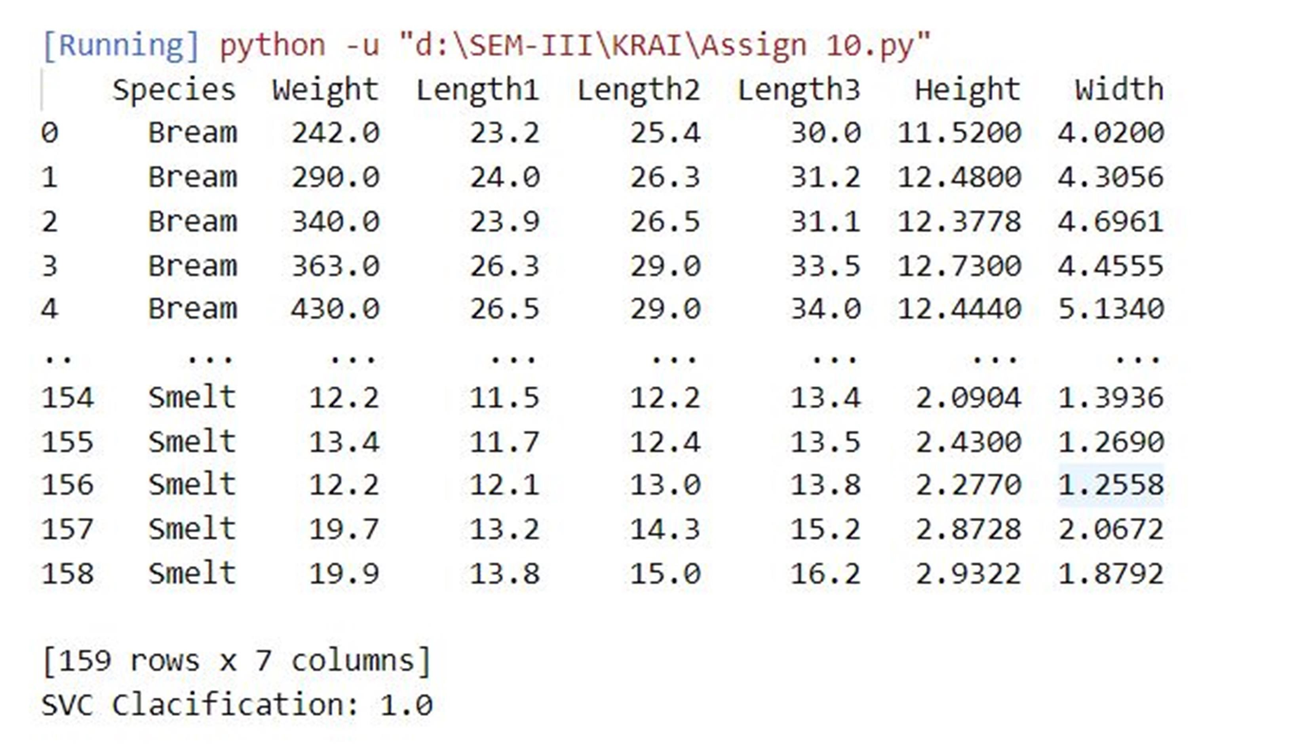

Program:

from monkeylearn import MonkeyLearn

ml = MonkeyLearn('4e1d801fabd0088150b8317b339f5665bdfb9972')

data = ['Very helpful and friendly staff.','Bed was extremely comfortable.']

model_id = 'cl_TKb7XmdG'

result = ml.classifiers.classify(model_id, data) print(result.body)

Output:

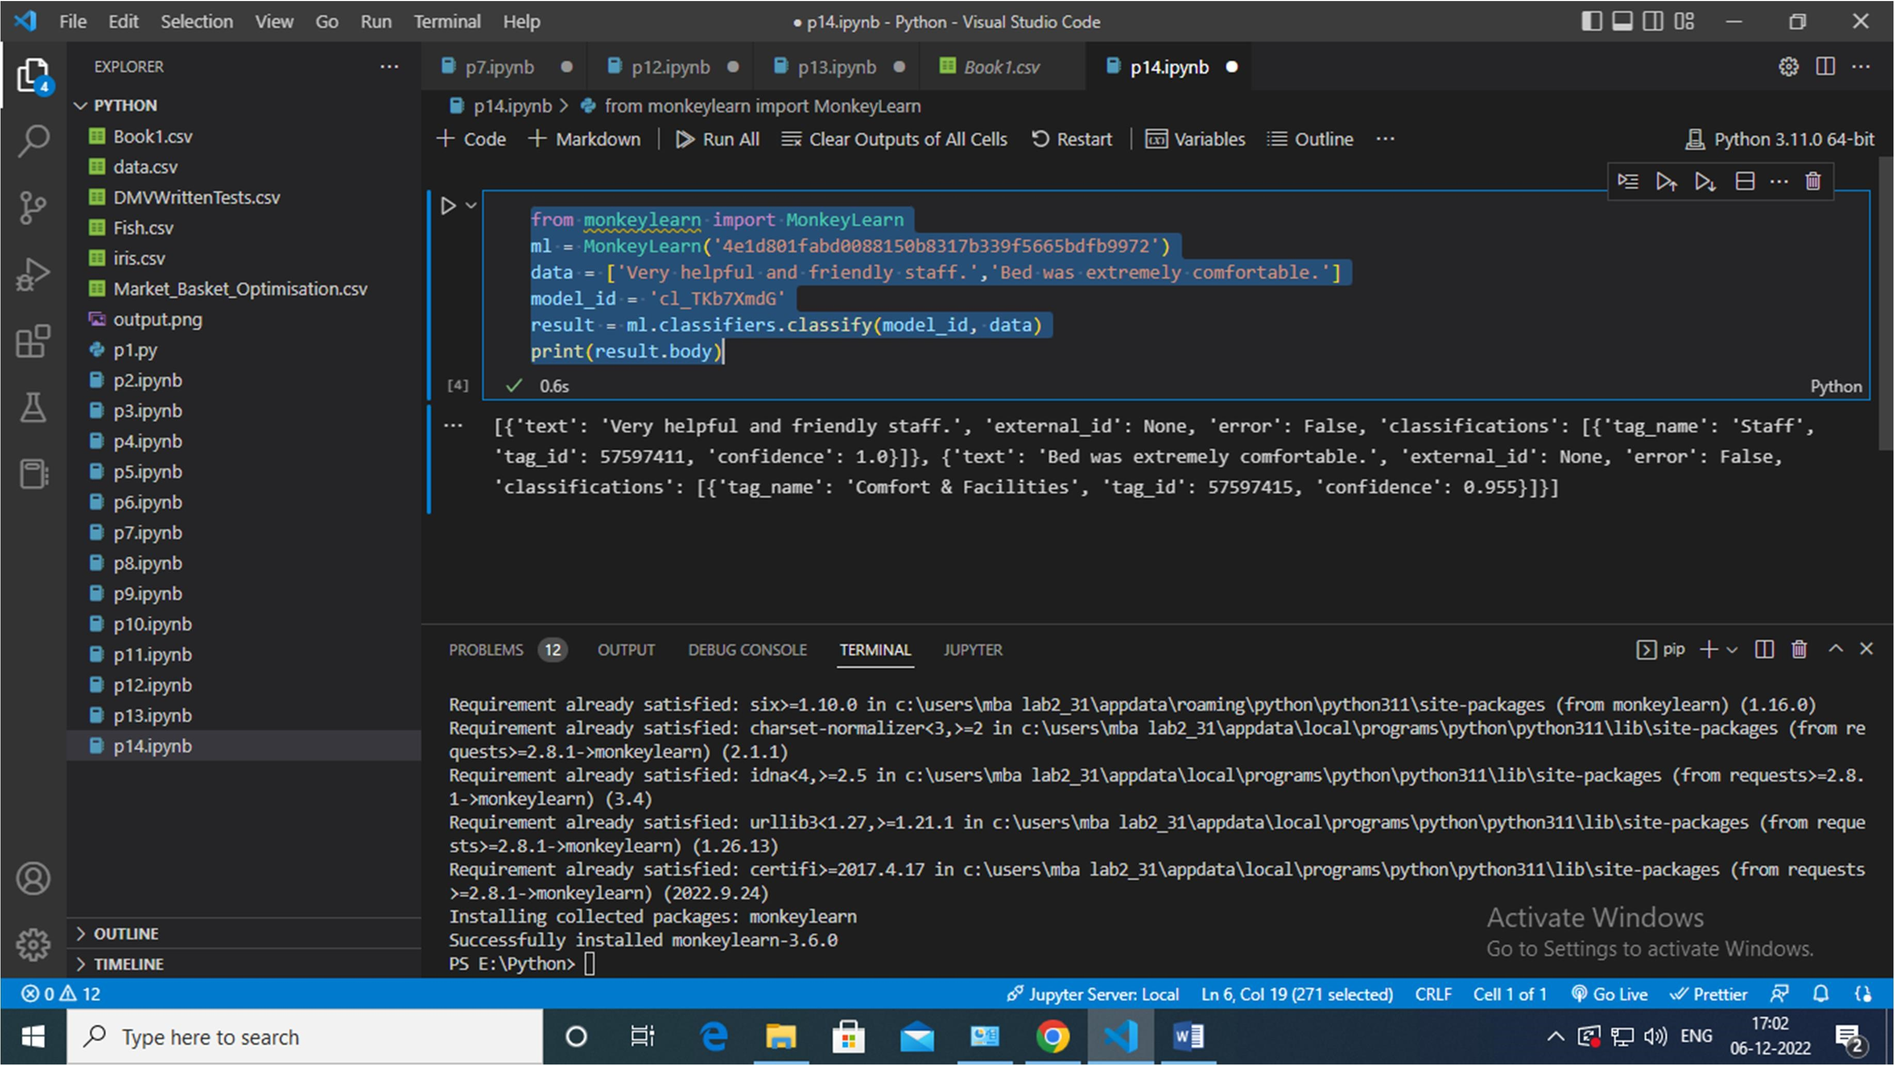

Program:

import matplotlib.pyplot as plt from kneed import KneeLocator from sklearn.datasets import make_blobs from sklearn.cluster import KMeans from sklearn.metrics import silhouette_score from sklearn.preprocessing import StandardScaler features, true_labels = make_blobs(

n_samples=200, centers=3, cluster_std=2.75,

random_state=42

)

features[:5] scaler = StandardScaler()

scaled_features = scaler.fit_transform(features) scaled_features[:5]

kmeans_kwargs = {

"init": "random",

"n_init": 10,

"max_iter": 300,

"random_state": 42,

} sse = [] for k in range(1, 11):

kmeans = KMeans(n_clusters=k, **kmeans_kwargs)

kmeans.fit(scaled_features) sse.append(kmeans.inertia_) plt.style.use("fivethirtyeight") plt.plot(range(1, 11), sse) plt.xticks(range(1, 11)) plt.xlabel("Number of Clusters") plt.ylabel("SSE") plt.show() silhouette_coefficients = []

for k in range(2, 11):

kmeans = KMeans(n_clusters=k, **kmeans_kwargs)

kmeans.fit(scaled_features)

score = silhouette_score(scaled_features, kmeans.labels_) silhouette_coefficients.append(score) plt.style.use("fivethirtyeight") plt.plot(range(2, 11), silhouette_coefficients) plt.xticks(range(2, 11)) plt.xlabel("Number of Clusters") plt.ylabel("Silhouette Coefficient") plt.show()

from sklearn.cluster import DBSCAN from sklearn.datasets import make_moons from sklearn.metrics import adjusted_rand_score features, true_labels = make_moons(

n_samples=250, noise=0.05, random_state=42

)

scaled_features = scaler.fit_transform(features) kmeans = KMeans(n_clusters=2) dbscan = DBSCAN(eps=0.3) kmeans.fit(scaled_features) dbscan.fit(scaled_features) kmeans_silhouette = silhouette_score( scaled_features, kmeans.labels_

).round(2)

dbscan_silhouette = silhouette_score( scaled_features, dbscan.labels_

).round (2) kmeans_silhouette

Output:

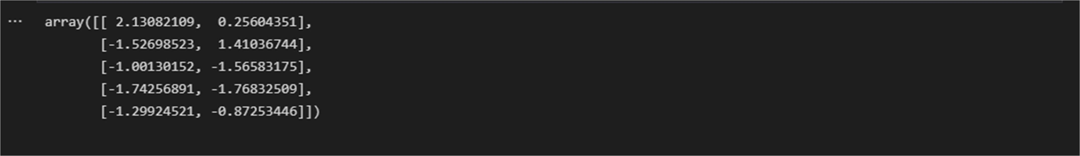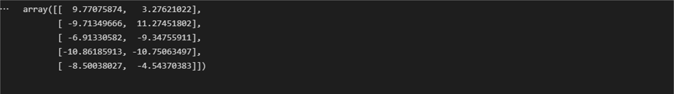

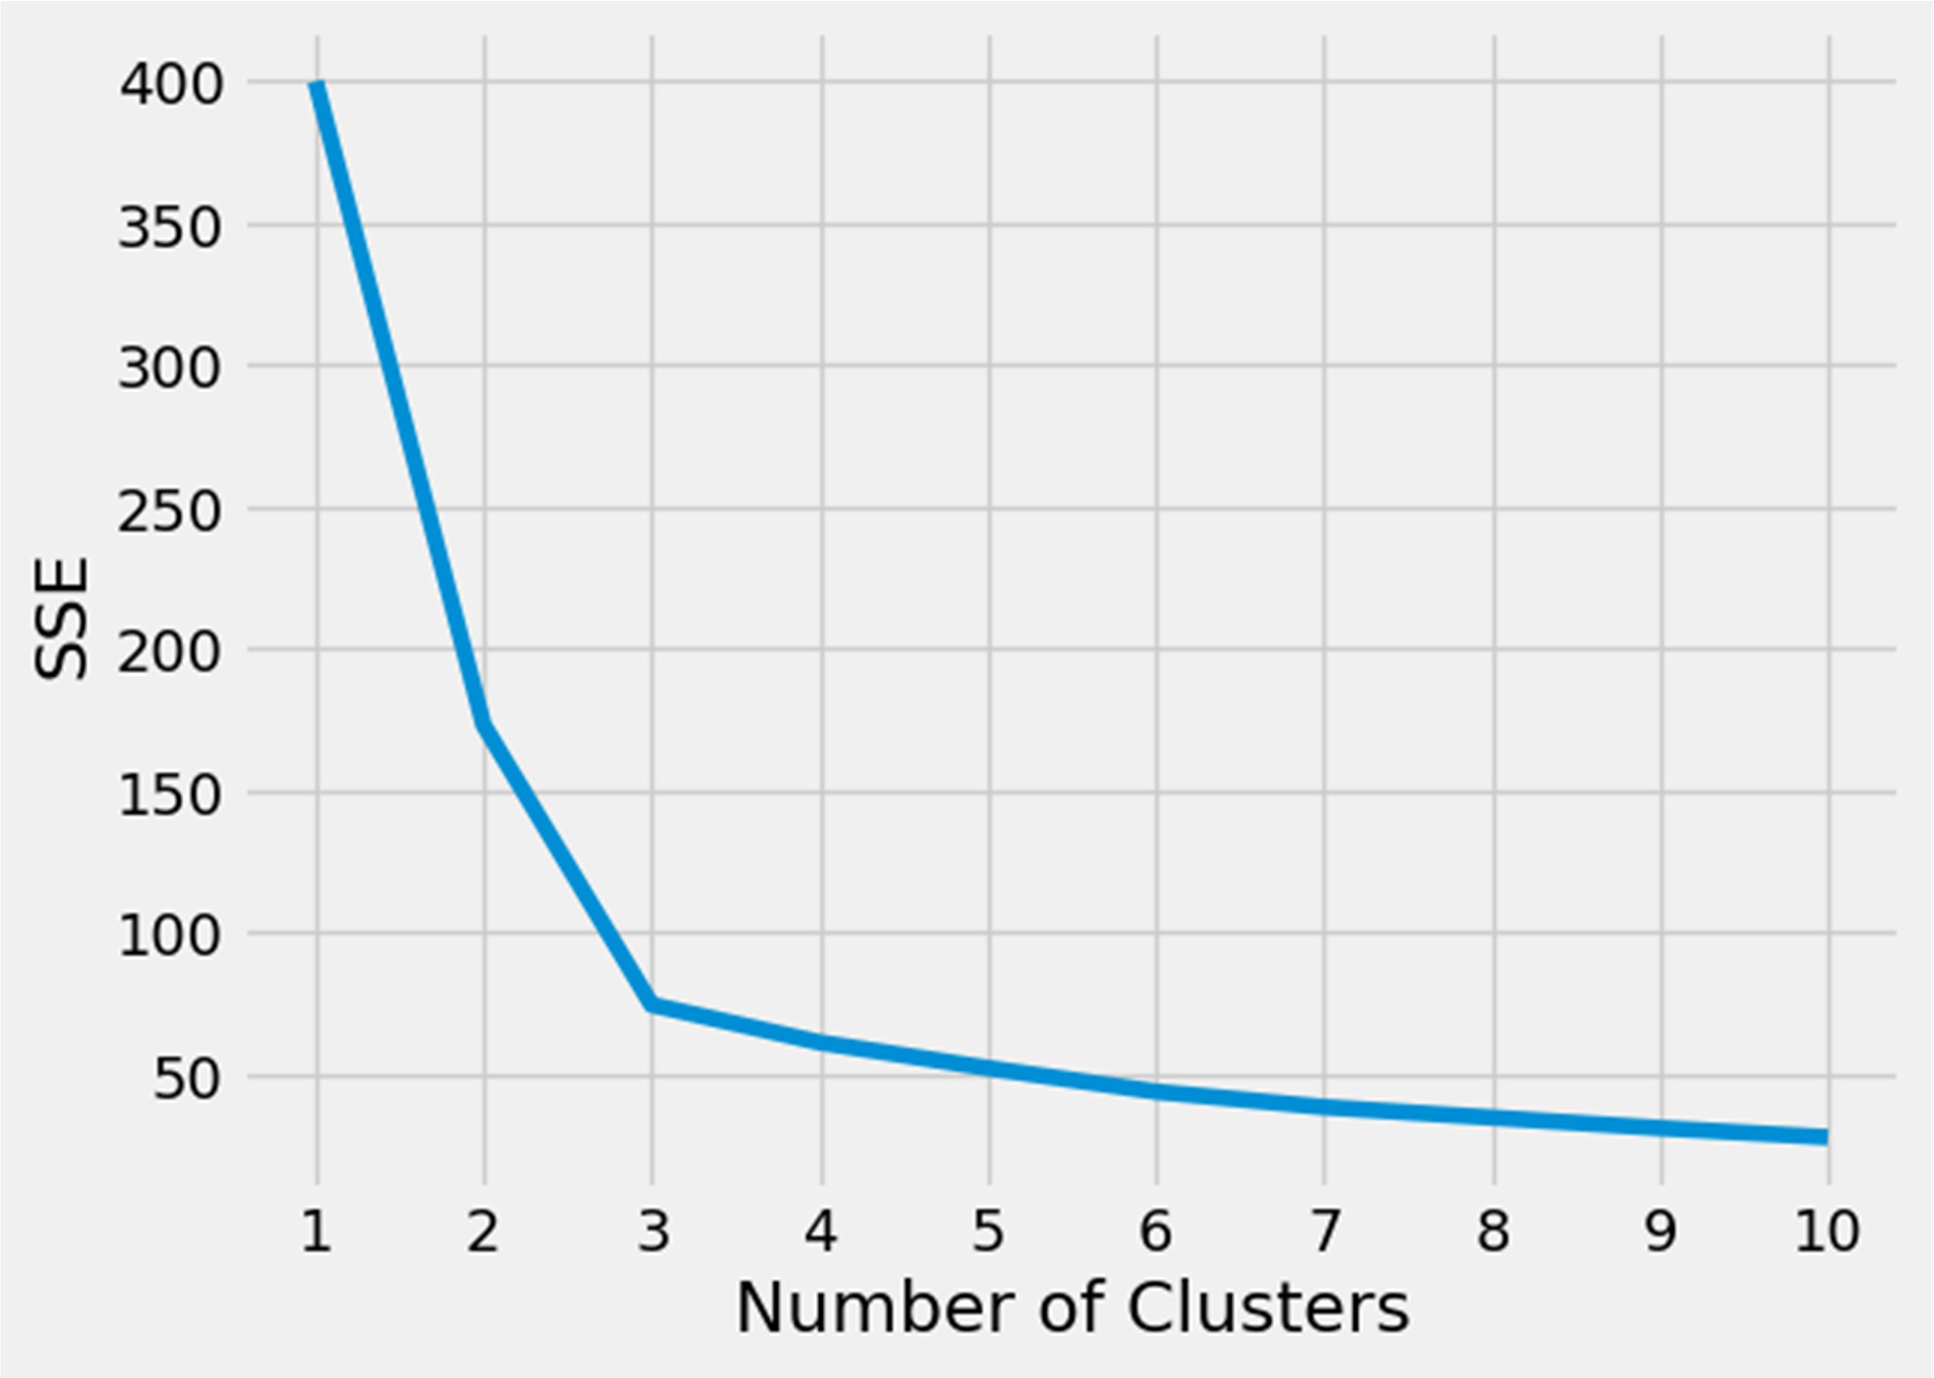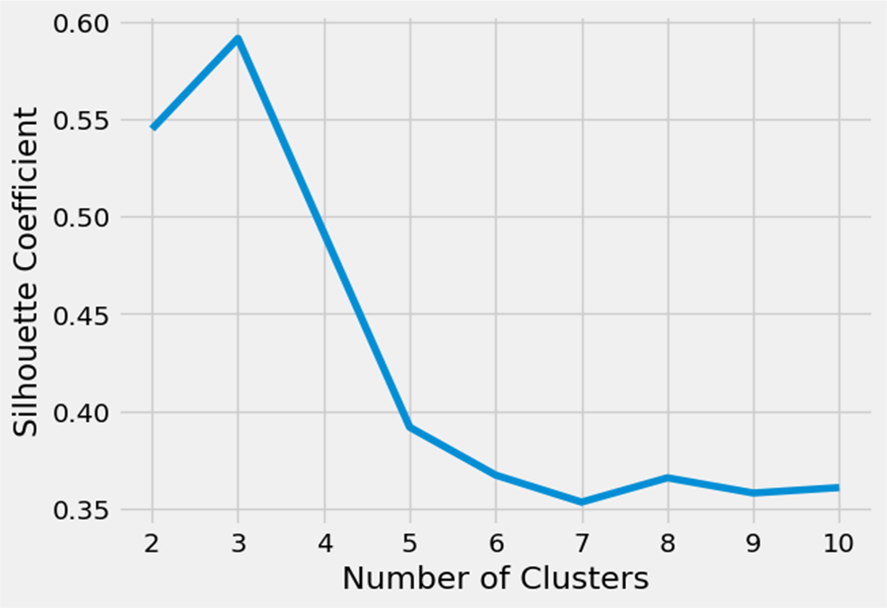

Program:

import numpy as np class NeuralNetwork(): def __init__(self, learning_rate): self.weights = np.array([np.random.randn(),np.random.randn()]) self.bias = np.random.randn()

self.learning_rate = learning_rate

def _sigmoid(self, x):

return 1 / (1 + np.exp(-x))

def _sigmoid_deriv(self, x):

return self._sigmoid(x) * (1 - self._sigmoid(x))

def predict(self, input_vector):

layer_1 = np.dot(input_vector, self.weights) + self.bias layer_2 = self._sigmoid(layer_1) prediction = layer_2 return prediction def _compute_gradients(self, input_vector, target):

layer_1 = np.dot(input_vector, self.weights) + self.bias layer_2 = self._sigmoid(layer_1) prediction = layer_2

derror_dprediction = 2 * (prediction - target) dprediction_dlayer1 = self._sigmoid_deriv(layer_1) dlayer1_dbias = 1

dlayer1_dweights = (0 * self.weights) + (1 *input_vector) derror_dbias = (

derror_dprediction * dprediction_dlayer1 *dlayer1_dbias

)

derror_dweights = (

derror_dprediction * dprediction_dlayer1 *dlayer1_dweights

)

return derror_dbias, derror_dweights

def _update_parameters(self, derror_dbias, derror_dweights):

self.bias = self.bias - (derror_dbias *self.learning_rate) self.weights = self.weights - ( derror_dweights * self.learning_rate) def train(self, input_vectors, targets, iterations):

cumulative_errors = [] for current_iteration in range(iterations):

random_data_index =np.random.randint(len(input_vectors)) input_vector = input_vectors[random_data_index] target = targets[random_data_index]

derror_dbias, derror_dweights =self._compute_gradients( input_vector, target ) self._update_parameters(derror_dbias,derror_dweights) if current_iteration % 100 == 0:

cumulative_error = 0 for data_instance_index in range(len(input_vectors)): data_point =input_vectors[data_instance_index] target = targets[data_instance_index] prediction = self.predict(data_point) error = np.square(prediction - target) cumulative_error = cumulative_error + error cumulative_errors.append(cumulative_error) return cumulative_errors

learning_rate = 0.1

neural_network = NeuralNetwork(learning_rate)

import matplotlib.pyplot as plt

input_vectors = np.array([

[3, 1.5],

[2, 1],

[4, 1.5],

[3, 4],

[3.5, 0.5],

[2, 0.5],

[5.5, 1],

[1, 1],

]

)

targets = np.array([0, 1, 0, 1, 0, 1, 1, 0])

learning_rate = 0.1

neural_network = NeuralNetwork(learning_rate)

training_error = neural_network.train(input_vectors, targets,10000) plt.plot(training_error) plt.xlabel("Iteons")

plt.ylabel("Error for ratiall training instances") plt.savefig("cumulative_error.png")

Output:

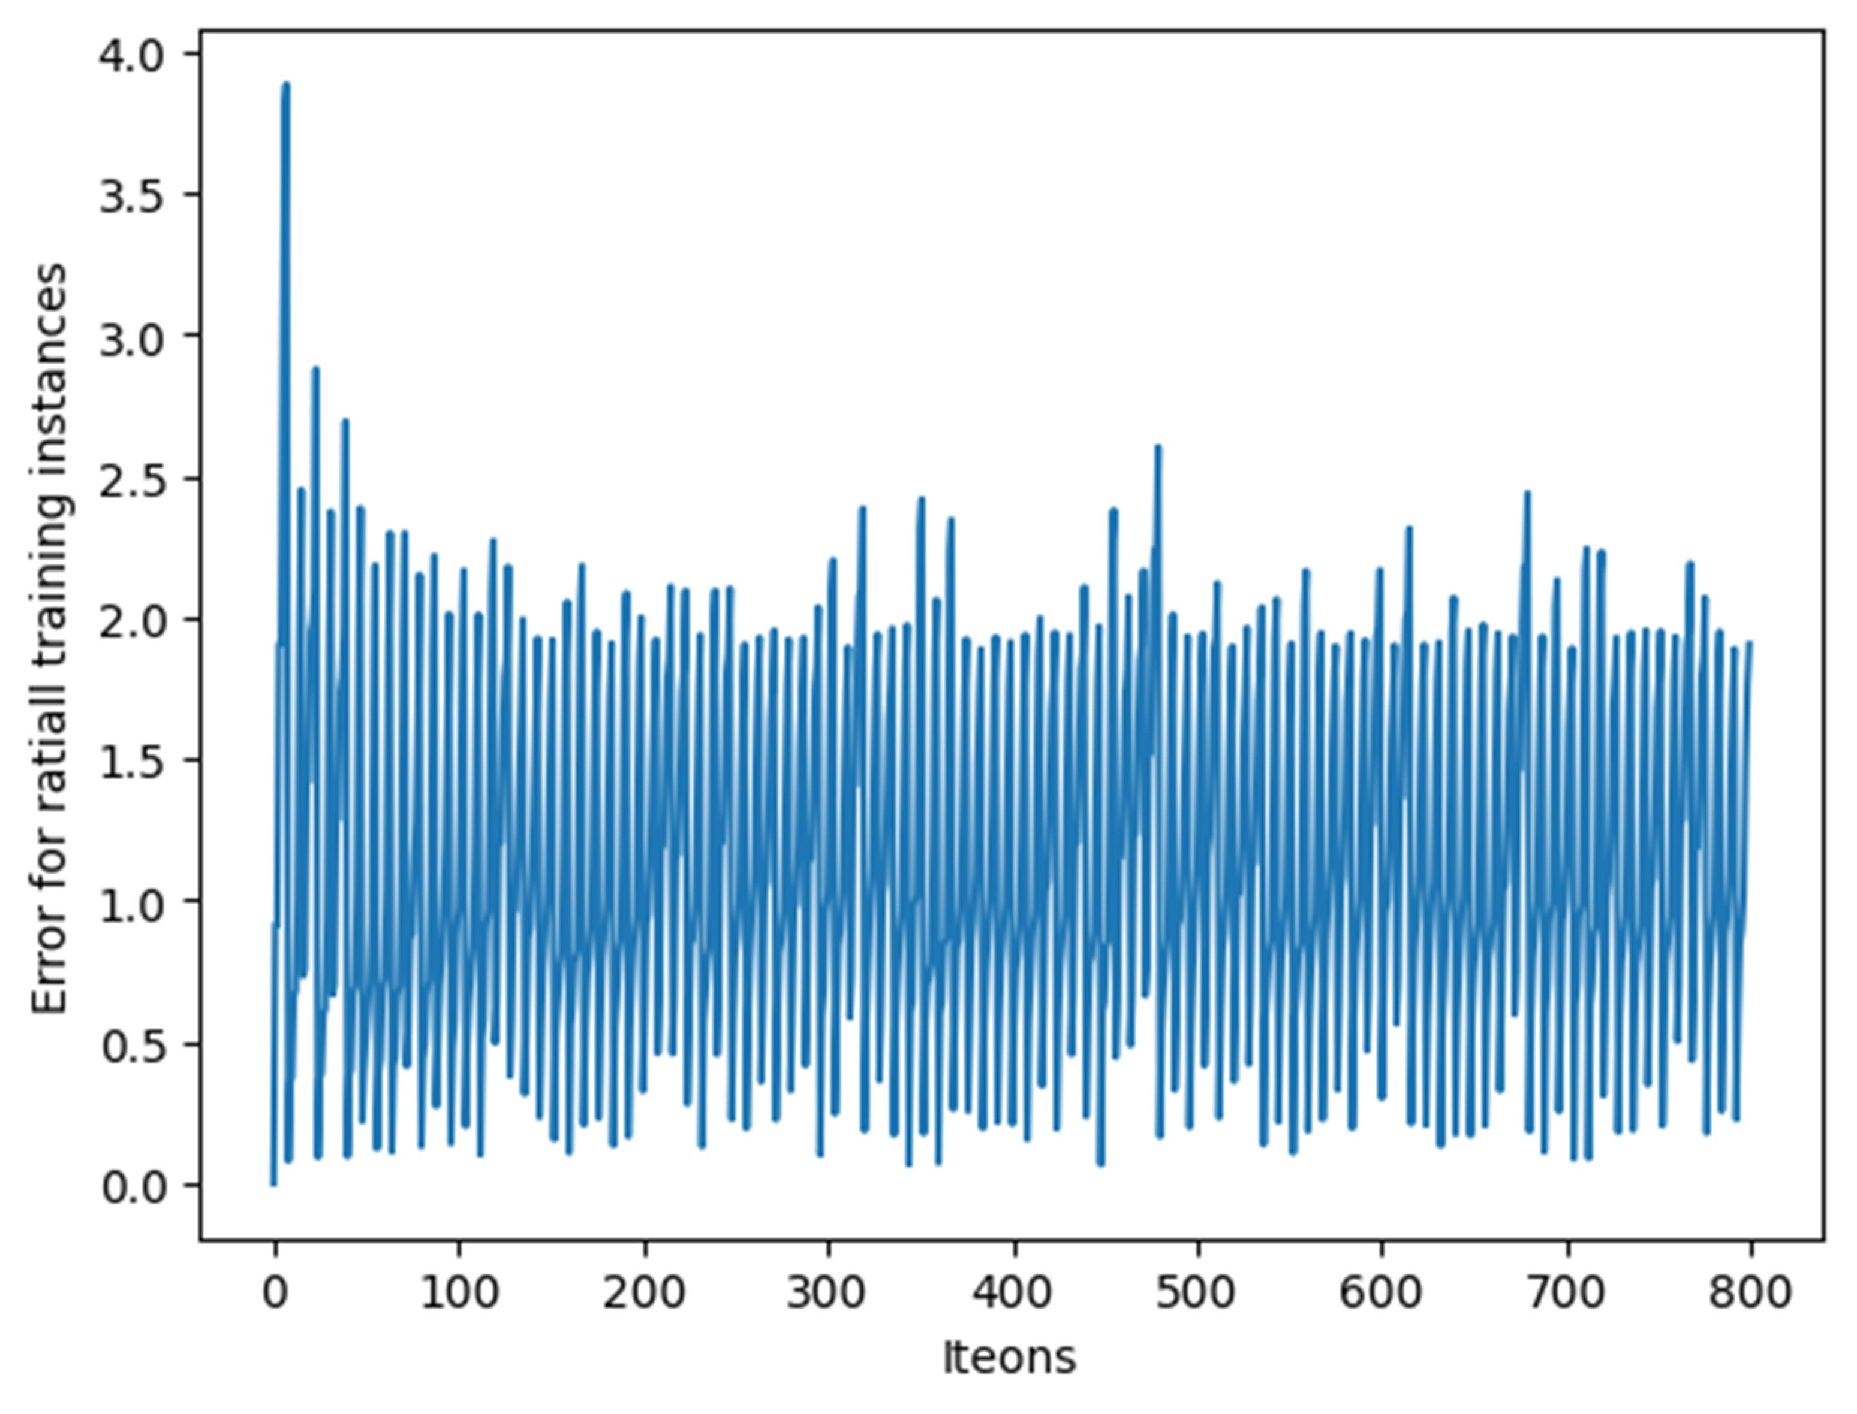

Program:

import math

import matplotlib.pyplot as plt from matplotlib.patches import Wedge def draw_neural_net(ax, left, right, bottom, top, layer_sizes):

n_layers = len(layer_sizes)

v_spacing = (top - bottom)/float(max(layer_sizes)) h_spacing = (right - left)/float(len(layer_sizes) - 1) for n, layer_size in enumerate(layer_sizes):

layer_top = v_spacing*(layer_size - 1)/2. + (top +bottom)/2. for m in range(layer_size):

circle = plt.Circle((n*h_spacing + left, layer_top -m*v_spacing), v_spacing/4.,color='w', ec='k', zorder=4)

ax.add_artist(circle)

for n, (layer_size_a, layer_size_b) in enumerate(zip(layer_sizes[:-1], layer_sizes[1:])): layer_top_a = v_spacing*(layer_size_a - 1)/2. + (top +bottom)/2. layer_top_b = v_spacing*(layer_size_b - 1)/2. + (top +bottom)/2.

for m in range(layer_size_a): for o in range(layer_size_b): line = plt.Line2D([n*h_spacing + left, (n +1)*h_spacing + left],[layer_top_a - m*v_spacing,layer_top_b - o*v_spacing], c='k')

ax.add_artist(line)

for n, (layer_size) in enumerate(layer_sizes): layer_top = v_spacing * (layer_size - 1) / 2. + (top +bottom) / 2. for m in range(layer_size):

center = (n * h_spacing + left, layer_top - m *v_spacing) radius = v_spacing / 4. if n > 0:

wedge_left = Wedge(center, r=radius, theta1=90,theta2=270, color='w', fc='g', ec='k', zorder=4)

wedge_right = Wedge(center, r=radius,theta1=270, theta2=90, color='w', fc='r', ec='k', zorder=4)

ax.add_artist(wedge_left) ax.add_artist(wedge_right) else:

circle = plt.Circle(center, radius, color='w',ec='k', zorder=4) ax.add_artist(circle) fig = plt.figure(figsize=(12, 12)) ax = fig.gca() ax.axis('off')

draw_neural_net(ax, .1, .9, .1, .9, [4, 7, 2]) fig.savefig('nn.png')

Output:

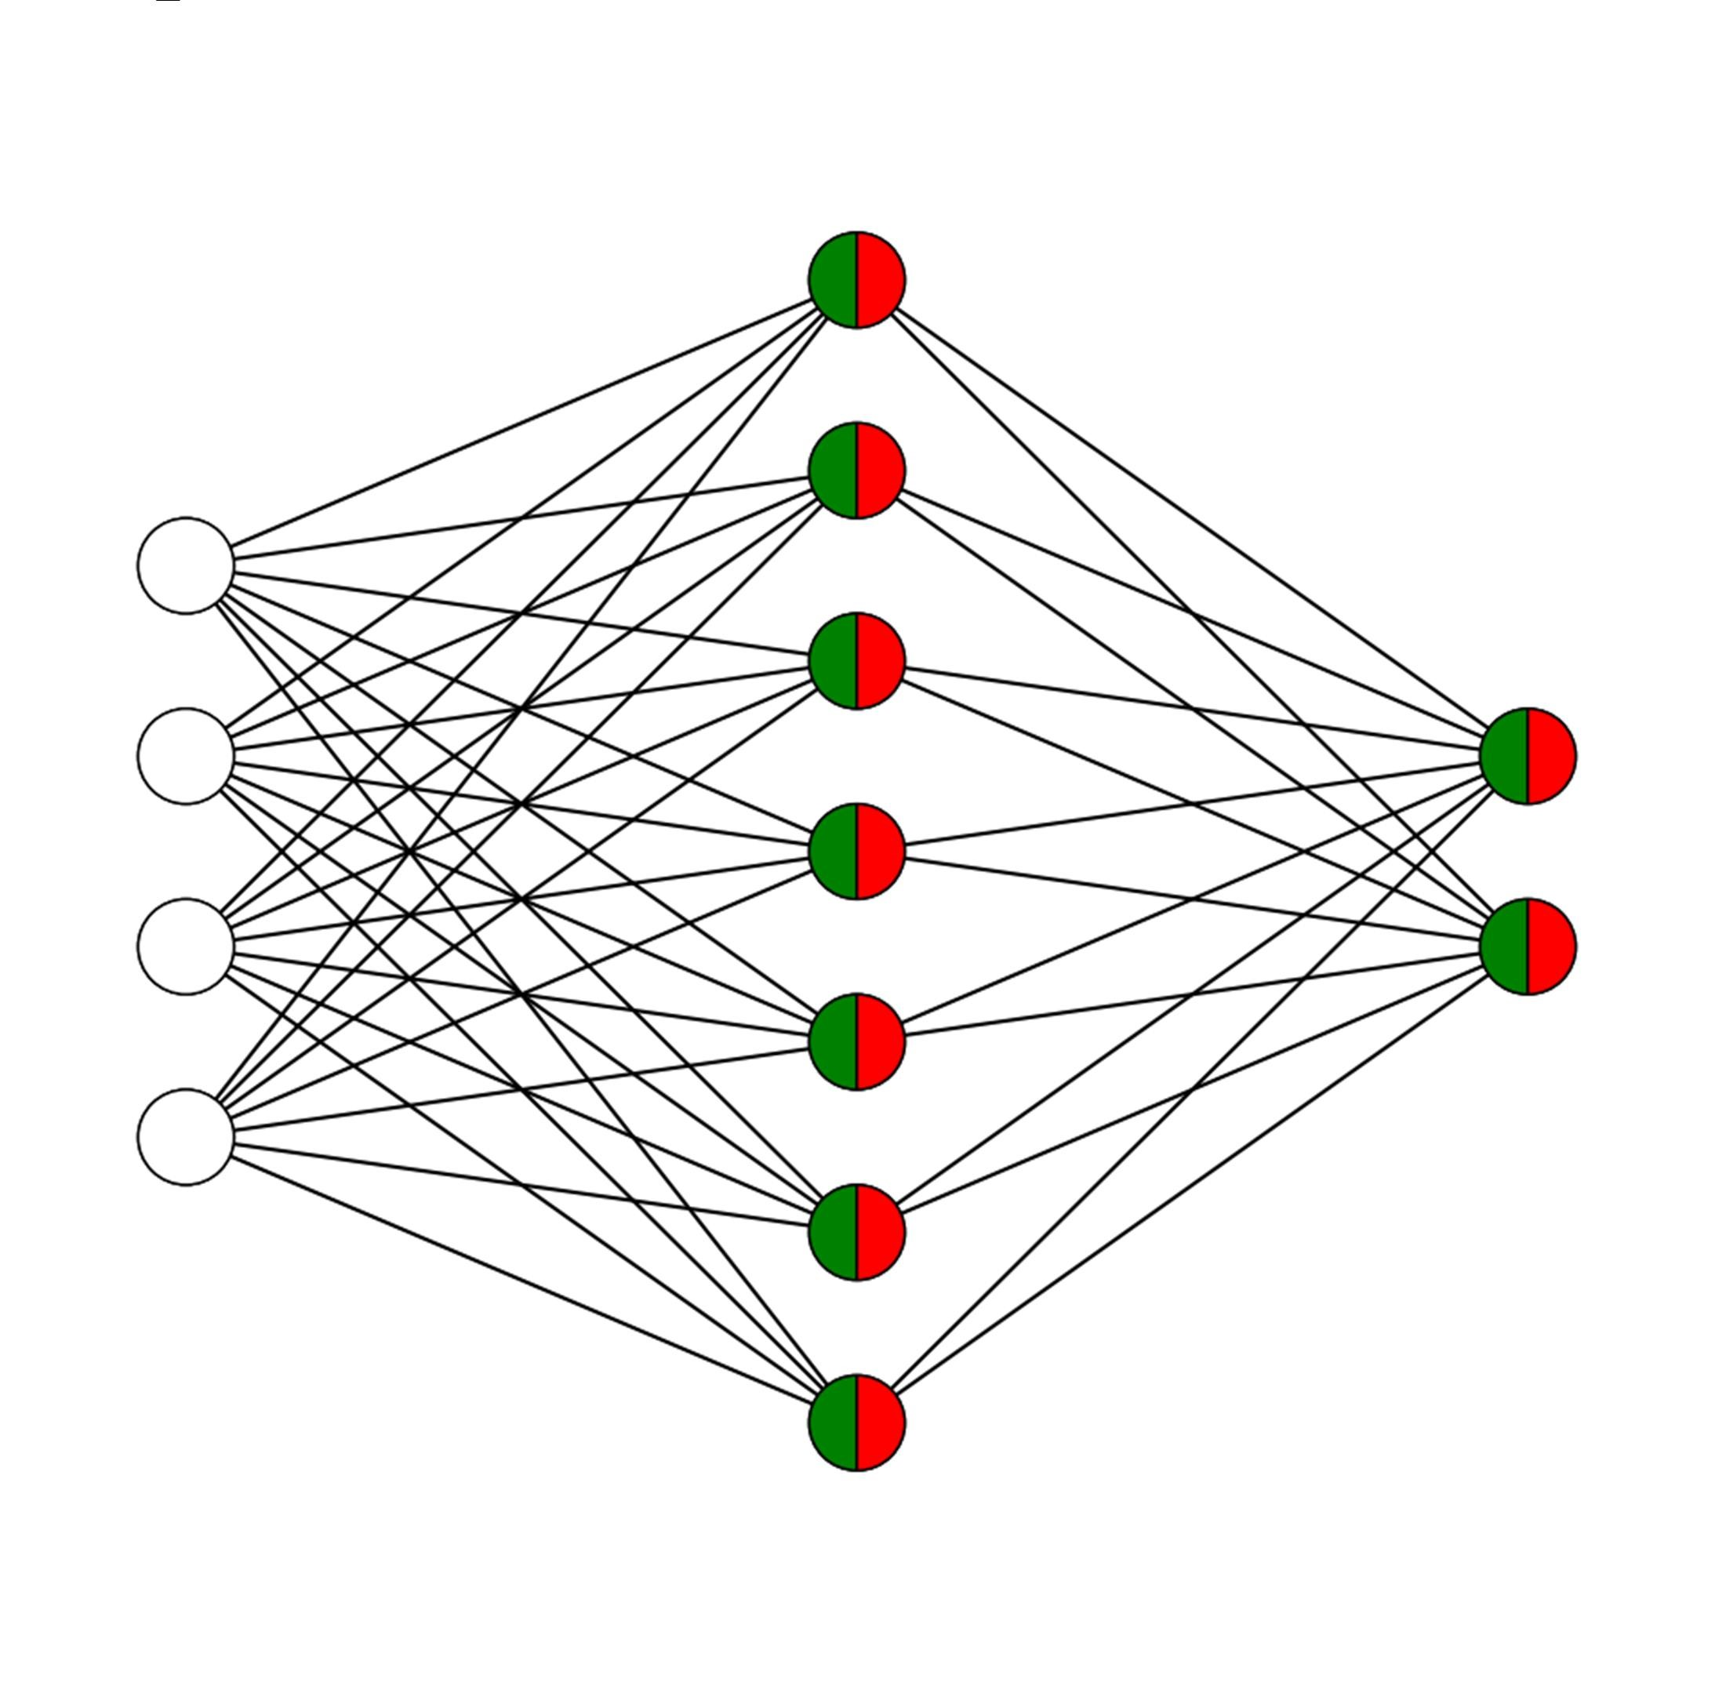

Program:

import os import sys import cv2

import numpy as np

input_f = 'letter.data' img_resize_factor = 12 start, end = 6, -1 height, width = 16, 8 with open(input_f, 'r') as f: for line in f.readlines():

data = np.array([255*float(x) for x in line.split('\t')[start:end]]) img = np.reshape(data, (height, width))

img_scaled = cv2.resize(img, None, fx=img_resize_factor, fy=img_resize_factor) print(line)

cv2.imshow('Img', img_scaled)

c = cv2.waitKey() if c == 27: break

Output:

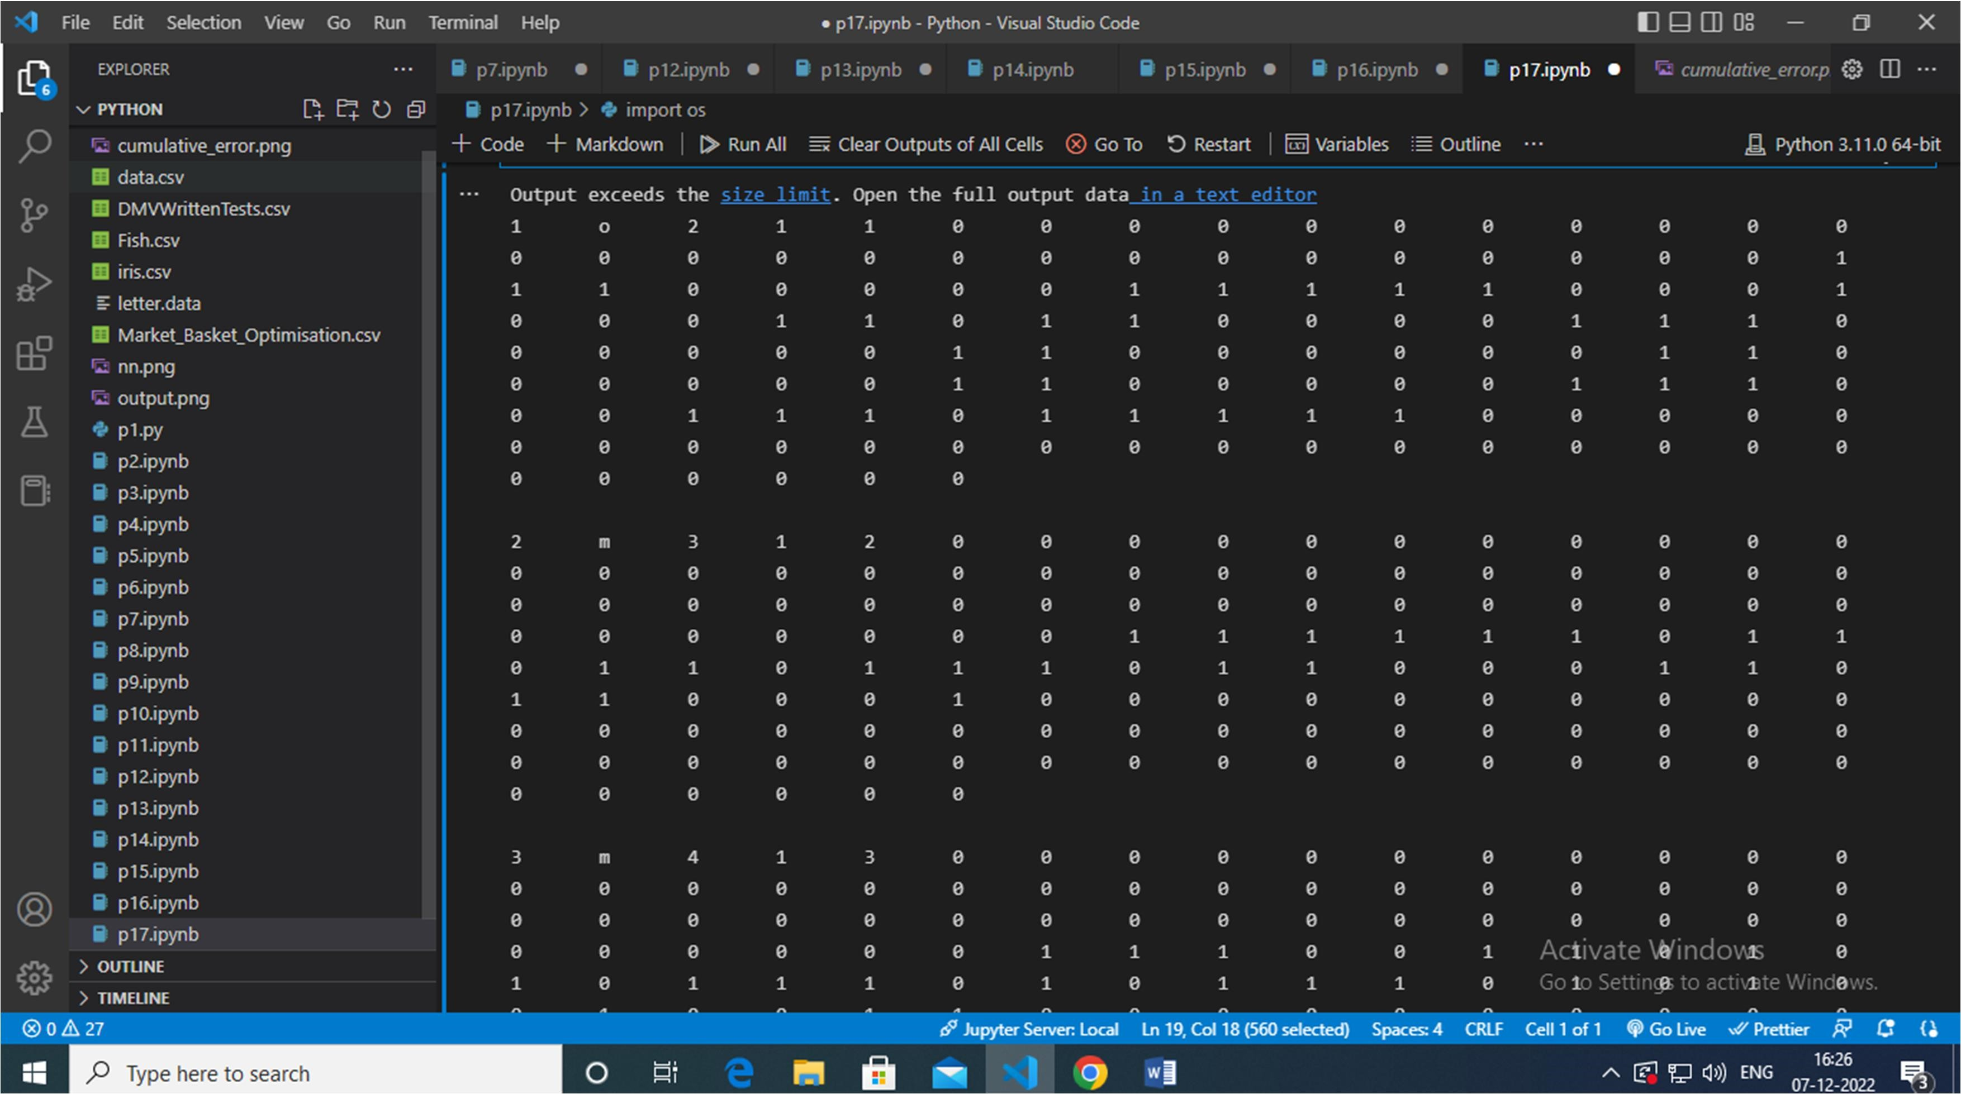

Program:

import cv2 import numpy as np

import os

from random import shuffle

from tqdm import tqdm

#Download the images of dogs and cats from the following

URL(https://www.kaggle.com/c/dogs-vs-cats-redux-kernels-edition/data) and extract it

TRAIN_DIR = 'E:/ Python / train'

TEST_DIR = 'E:/Python/test'

IMG_SIZE = 50

LR = 1e-3

MODEL_NAME = 'dogvscats-{}-{}.model'.format(LR, '6conv-basic-video')

def label_img(img):

word_label = img.split('.')[-3] if word_label == 'cat': return [1,0]

elif word_label == 'dog': return [0,1]

def create_train_data(): training_data = [] for img in tqdm(os.listdir(TRAIN_DIR)): label = label_img(img)

path = os.path.join(TRAIN_DIR,img)

img = cv2.resize(cv2.imread(path, cv2.IMREAD_GRAYSCALE), (IMG_SIZE, IMG_SIZE))

training_data.append([np.array(img), np.array(label)]) shuffle(training_data)

np.save('train_data.npy', training_data) return training_data

def process_test_data():

testing_data = [] for img in tqdm(os.listdir(TEST_DIR)): path = os.path.join(TEST_DIR,img) img_num = img.split('.')[0]

img = cv2.resize(cv2.imread(path,cv2.IMREAD_GRAYSCALE), (IMG_SIZE,IMG_SIZE))

testing_data.append([np.array(img), img_num])

np.save('test_data.npy',testing_data) return testing_data

import tflearn

from tflearn.layers.conv import conv_2d, max_pool_2d from tflearn.layers.core import input_data, dropout, fully_connected from tflearn.layers.estimator import regression

convnet = input_data(shape=[None, IMG_SIZE, IMG_SIZE, 1], name='input')

convnet = conv_2d(convnet, 32, 2, activation='relu')

convnet = max_pool_2d(convnet, 2)

convnet = conv_2d(convnet, 64, 2, activation='relu')

convnet = max_pool_2d(convnet, 2)

convnet = conv_2d(convnet, 32, 2, activation='relu')

convnet = max_pool_2d(convnet, 2)

convnet = conv_2d(convnet, 64, 2, activation='relu')

convnet = max_pool_2d(convnet, 2)

convnet = conv_2d(convnet, 32, 2, activation='relu')

convnet = max_pool_2d(convnet, 2)

convnet = conv_2d(convnet, 64, 2, activation='relu')

convnet = max_pool_2d(convnet, 2)

convnet = fully_connected(convnet, 1024, activation='relu') convnet = dropout(convnet, 0.8)

convnet = fully_connected(convnet, 2, activation='softmax') convnet = regression(convnet, optimizer='adam', learning_rate=LR, loss='categorical_crossentropy', name='targets')

model = tflearn.DNN(convnet, tensorboard_dir='log')

if os.path.exists('{}.meta'.format(MODEL_NAME)):

model.load(MODEL_NAME) print('model loaded!')

train = train_data[:-500] test = train_data[-500:] X = np.array([i[0] for i in train]).reshape(-1, IMG_SIZE, IMG_SIZE, 1)

Y = [i[1] for i in train]

test_x = np.array([i[0] for i in test]).reshape(-1, IMG_SIZE, IMG_SIZE, 1) test_y = [i[1] for i in test]

model.fit({'input': X}, {'targets': Y}, n_epoch=5, validation_set=({'input': test_x}, {'targets':

test_y}),

snapshot_step=500, show_metric=True, run_id=MODEL_NAME)

model.save(MODEL_NAME)

#tensorboard --logdir=/home/ngacha/Machine Learning/log

import matplotlib.pyplot as plt #test_data = process_test_data()

test_data = np.load('test_data.npy')

fig = plt.figure()

for num, data in enumerate(test_data[:12]):

img_num = data[1]

img_data = data[0]

y = fig.add_subplot(3,4,num+1) orig = img_data

data = img_data.reshape(IMG_SIZE, IMG_SIZE, 1)

model_out = model.predict([data])[0]

if np.argmax(model_out) == 1: str_label='Dog' else: str_label = 'Cat'

y.imshow(orig, cmap='gray')

plt.title(str_label)

y.axes.get_xaxis().set_visible(False)

y.axes.get_yaxis().set_visible(False) plt.show()

with open('submission-file.csv', 'w') as f: f.write('id,label\n') with open('submission-file.csv', 'w') as f:

for data in tqdm(test_data):

img_num = data[1] img_data = data[0] orig = img_data

data = img_data.reshape(IMG_SIZE, IMG_SIZE, 1) model_out = model.predict([data])[0]

f.write('{},{}\n'.format(img_num,model_out[1]))

Output:

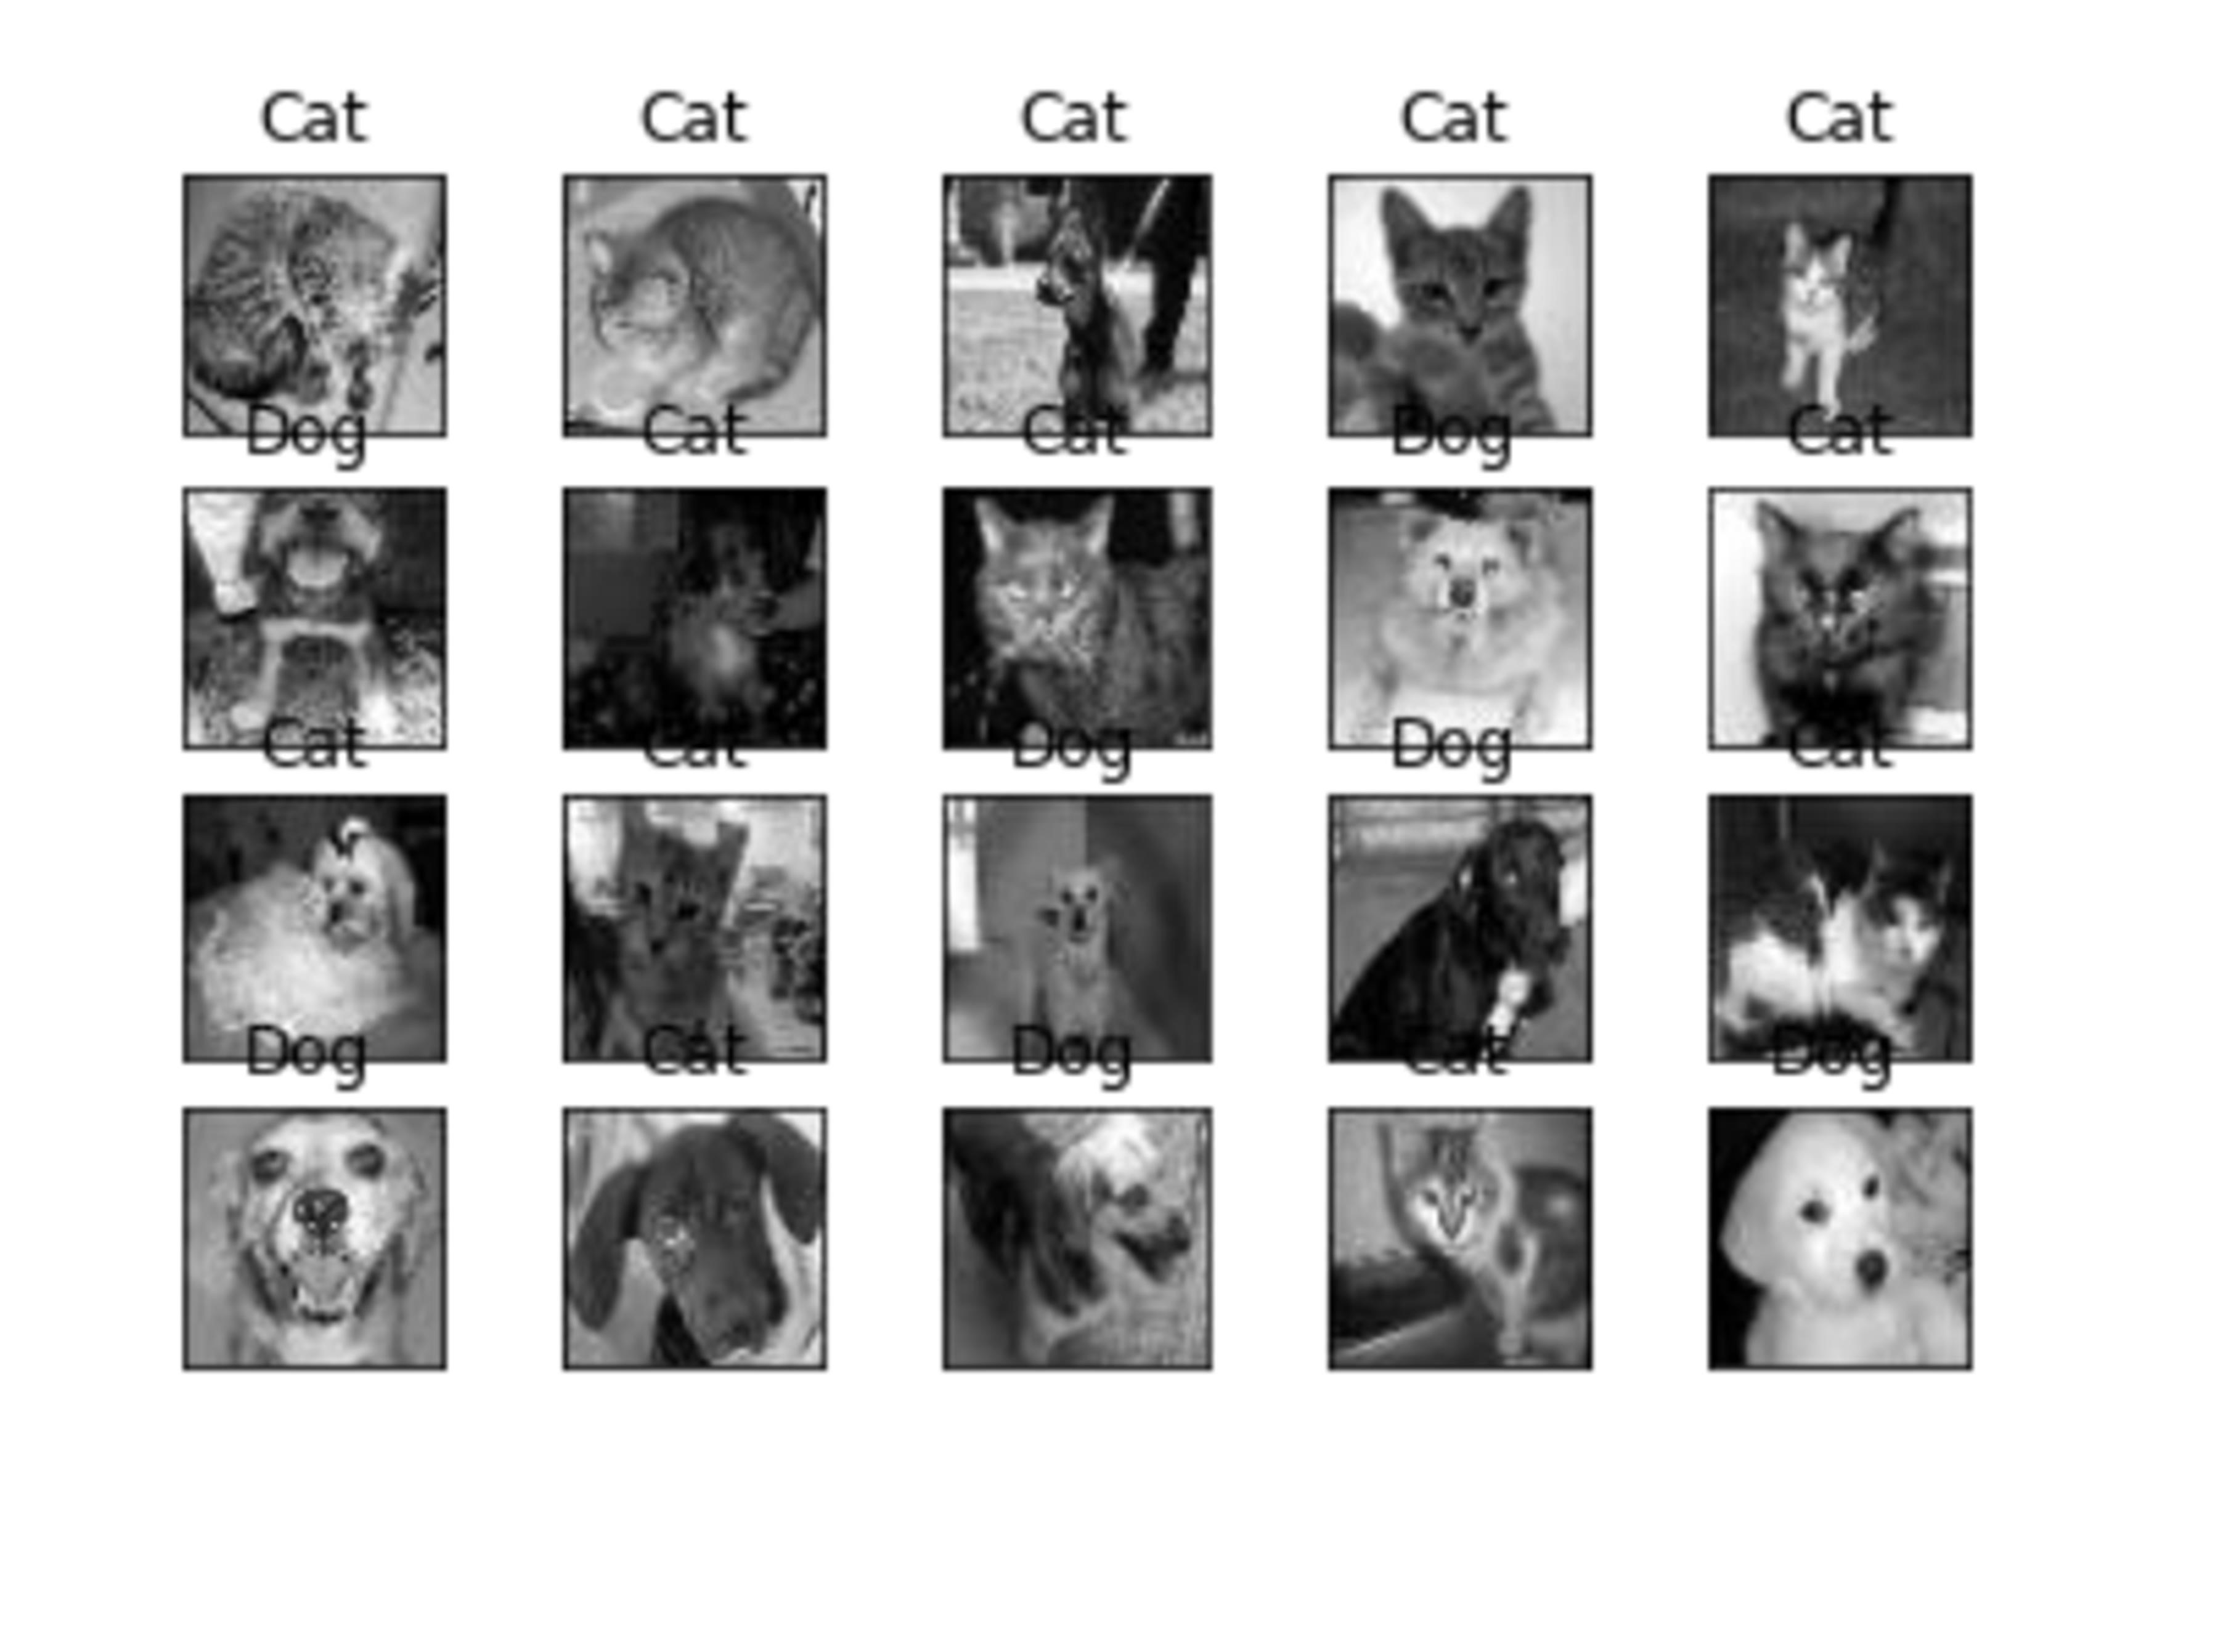

Program:

%load_ext autoreload %autoreload 2

from IPython.core.interactiveshell import InteractiveShell

from IPython.display import HTML

InteractiveShell.ast_node_interactivity = 'all'

import warnings

warnings.filterwarnings('ignore', category = RuntimeWarning) warnings.filterwarnings('ignore', category = UserWarning) import pandas as pd import numpy as np from utils import *

data =pd.read_csv('neural_network_patent_query.csv') data.head()

Output:

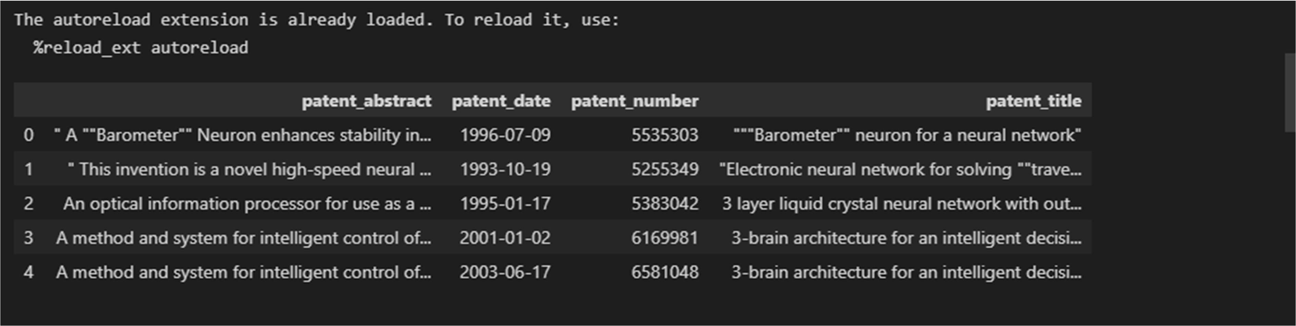

Program:

from keras.models import Sequential, load_model

from keras.layers import LSTM, Dense, Dropout, Embedding,Masking, Bidirectional from tensorflow.keras.optimizers import Adam from tensorflow.keras.utils import plot_model model = Sequential() model.add( Embedding(

input_dim=len(word_idx) + 1, output_dim=100, weights=None,

trainable=True))

model.add(

LSTM(64, return_sequences=False, dropout=0.1, recurrent_dropout=0.1)

)

model.add(Dense(64, activation='relu')) model.add(Dropout(0.5))

model.add(Dense(len(word_idx) + 1, activation='softmax')) model.compile(

optimizer='adam', loss='categorical_crossentropy',metrics=['accuracy']) model.summary()

Output:

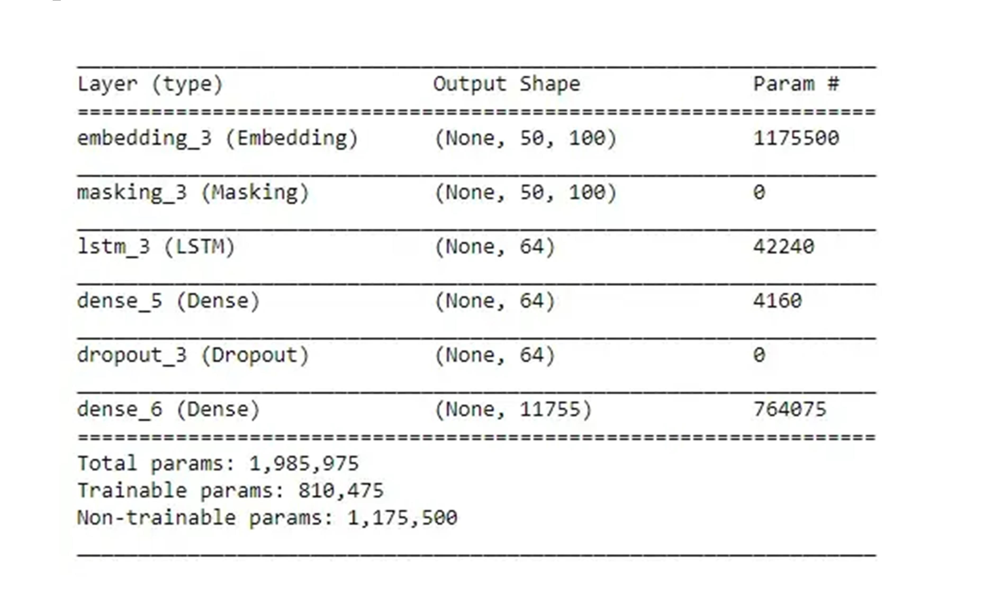

Program:

import numpy as np import matplotlib.pyplot as plt import keras from keras.layers import Input, Dense, Reshape, Flatten, Dropout from keras.layers import BatchNormalization, Activation,ZeroPadding2D from keras.layers import LeakyReLU from keras.layers.convolutional import UpSampling2D, Conv2D from keras.models import Sequential, Model

from tensorflow.keras.optimizers import Adam,SGD

(X, y), (_, _) = keras.datasets.cifar10.load_data() X = X[y.flatten() == 8] image_shape = (32, 32, 3) latent_dimensions = 100 def build_generator(): model = Sequential()

model.add(Dense(128 * 8 * 8, activation="relu",input_dim=latent_dimensions)) model.add(Reshape((8, 8, 128))) model.add(UpSampling2D())

model.add(Conv2D(128, kernel_size=3, padding="same")) model.add(BatchNormalization(momentum=0.78))

model.add(Activation("relu")) model.add(UpSampling2D())

model.add(Conv2D(64, kernel_size=3, padding="same")) model.add(BatchNormalization(momentum=0.78))

model.add(Activation("relu"))

model.add(Conv2D(3, kernel_size=3, padding="same"))

model.add(Activation("tanh")) noise = Input(shape=(latent_dimensions,)) image = model(noise)

return Model(noise, image) def build_discriminator(): model = Sequential()

model.add(Conv2D(32, kernel_size=3, strides=2,input_shape=image_shape,padding="same

"))

model.add(LeakyReLU(alpha=0.2)) model.add(Dropout(0.25))

model.add(Conv2D(64, kernel_size=3, strides=2,padding="same")) model.add(ZeroPadding2D(padding=((0,1),(0,1)))) model.add(BatchNormalization(momentum=0.82)) model.add(LeakyReLU(alpha=0.25)) model.add(Dropout(0.25))

model.add(Conv2D(128, kernel_size=3, strides=2,padding="same")) model.add(BatchNormalization(momentum=0.82)) model.add(LeakyReLU(alpha=0.2)) model.add(Dropout(0.25))

model.add(Conv2D(256, kernel_size=3, strides=1,padding="same")) model.add(BatchNormalization(momentum=0.8)) model.add(LeakyReLU(alpha=0.25)) model.add(Dropout(0.25)) model.add(Flatten())

model.add(Dense(1, activation='sigmoid')) image = Input(shape=image_shape)

validity = model(image)

return Model(image, validity) def display_images(): r, c = 4,4

noise = np.random.normal(0, 1, (r *c,latent_dimensions)) generated_images = generator.predict(noise) generated_images = 0.5 * generated_images + 0.5

fig, axs = plt.subplots(r, c)

count = 0 for i in range(r): for j in range(c): axs[i,j].imshow(generated_images[count,:,:,]) axs[i,j].axis('off')

count += 1

plt.show()

plt.close()

discriminator = build_discriminator()

discriminator.compile(loss='binary_crossentropy',optimizer=Adam(0.0002,0.5),metrics=['acc uracy'])

discriminator.trainable = False generator = build_generator() z = Input(shape=(latent_dimensions,)) image = generator(z) valid = discriminator(image) combined_network = Model(z, valid) combined_network.compile(loss='binary_crossentropy',optimizer=Adam(0.0002,0.5)) num_epochs=15000 batch_size=32 display_interval=2500

losses=[] X = (X / 127.5) - 1.

valid = np.ones((batch_size, 1)) valid += 0.05 * np.random.random(valid.shape)

fake = np.zeros((batch_size, 1)) fake += 0.05 * np.random.random(fake.shape) for epoch in range(num_epochs):

index = np.random.randint(0, X.shape[0],batch_size) images = X[index]

noise = np.random.normal(0, 1, (batch_size,latent_dimensions)) generated_images = generator.predict(noise) discm_loss_real =discriminator.train_on_batch(images, valid) discm_loss_fake =discriminator.train_on_batch(generated_images, fake) discm_loss = 0.5 * np.add(discm_loss_real,discm_loss_fake) genr_loss =combined_network.train_on_batch(noise, valid) if epoch % display_interval == 6:

display_images()

Output:

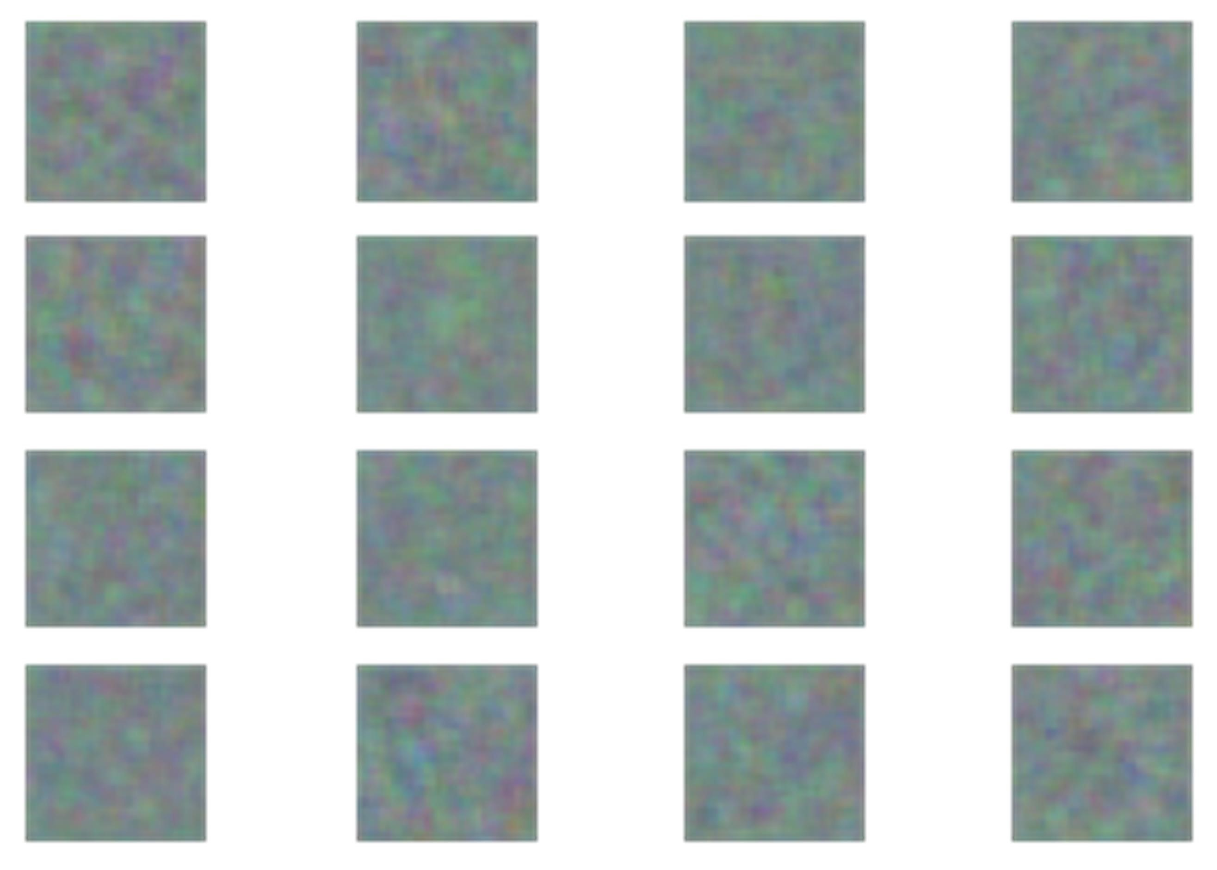

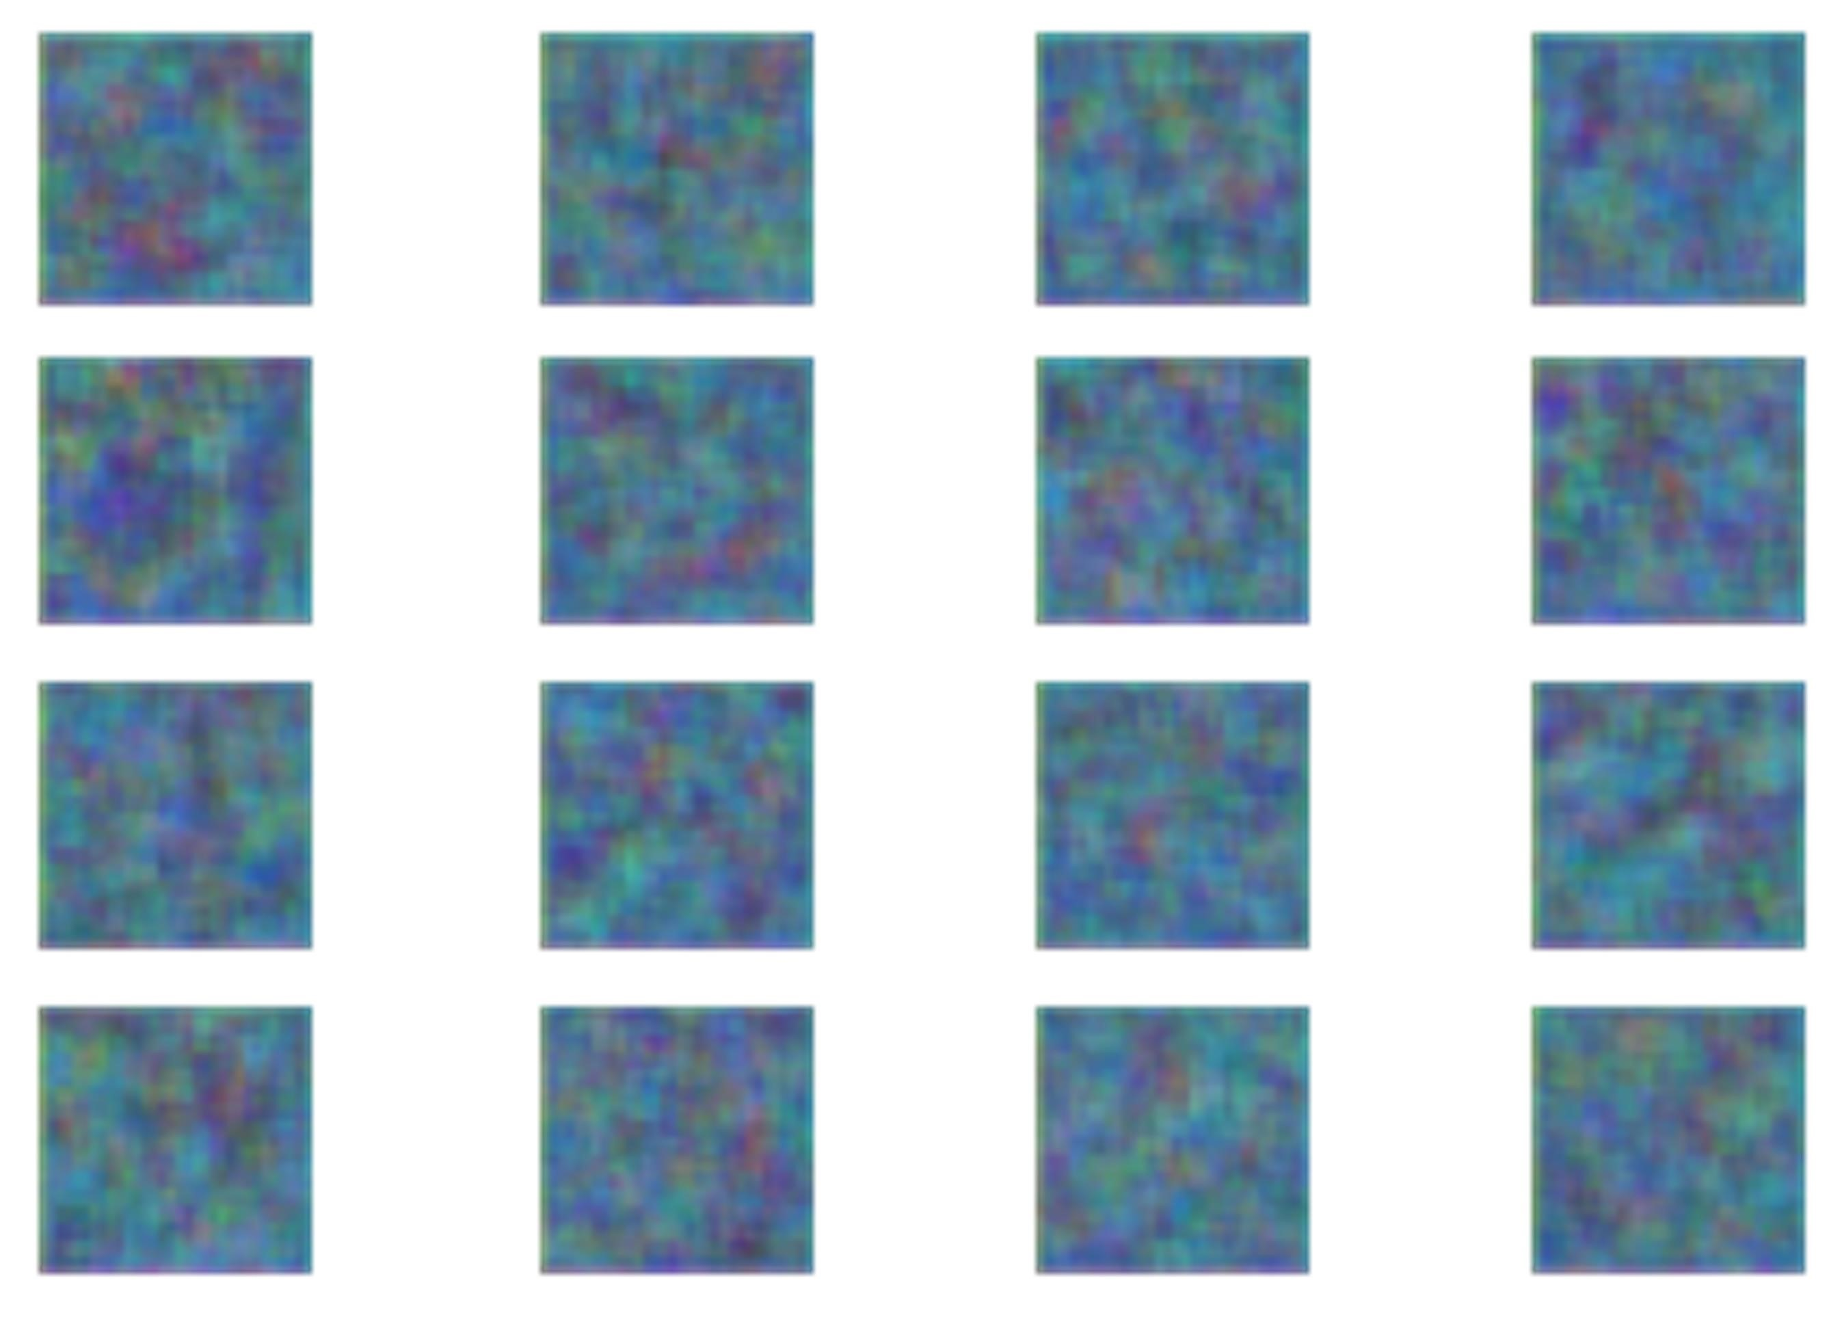

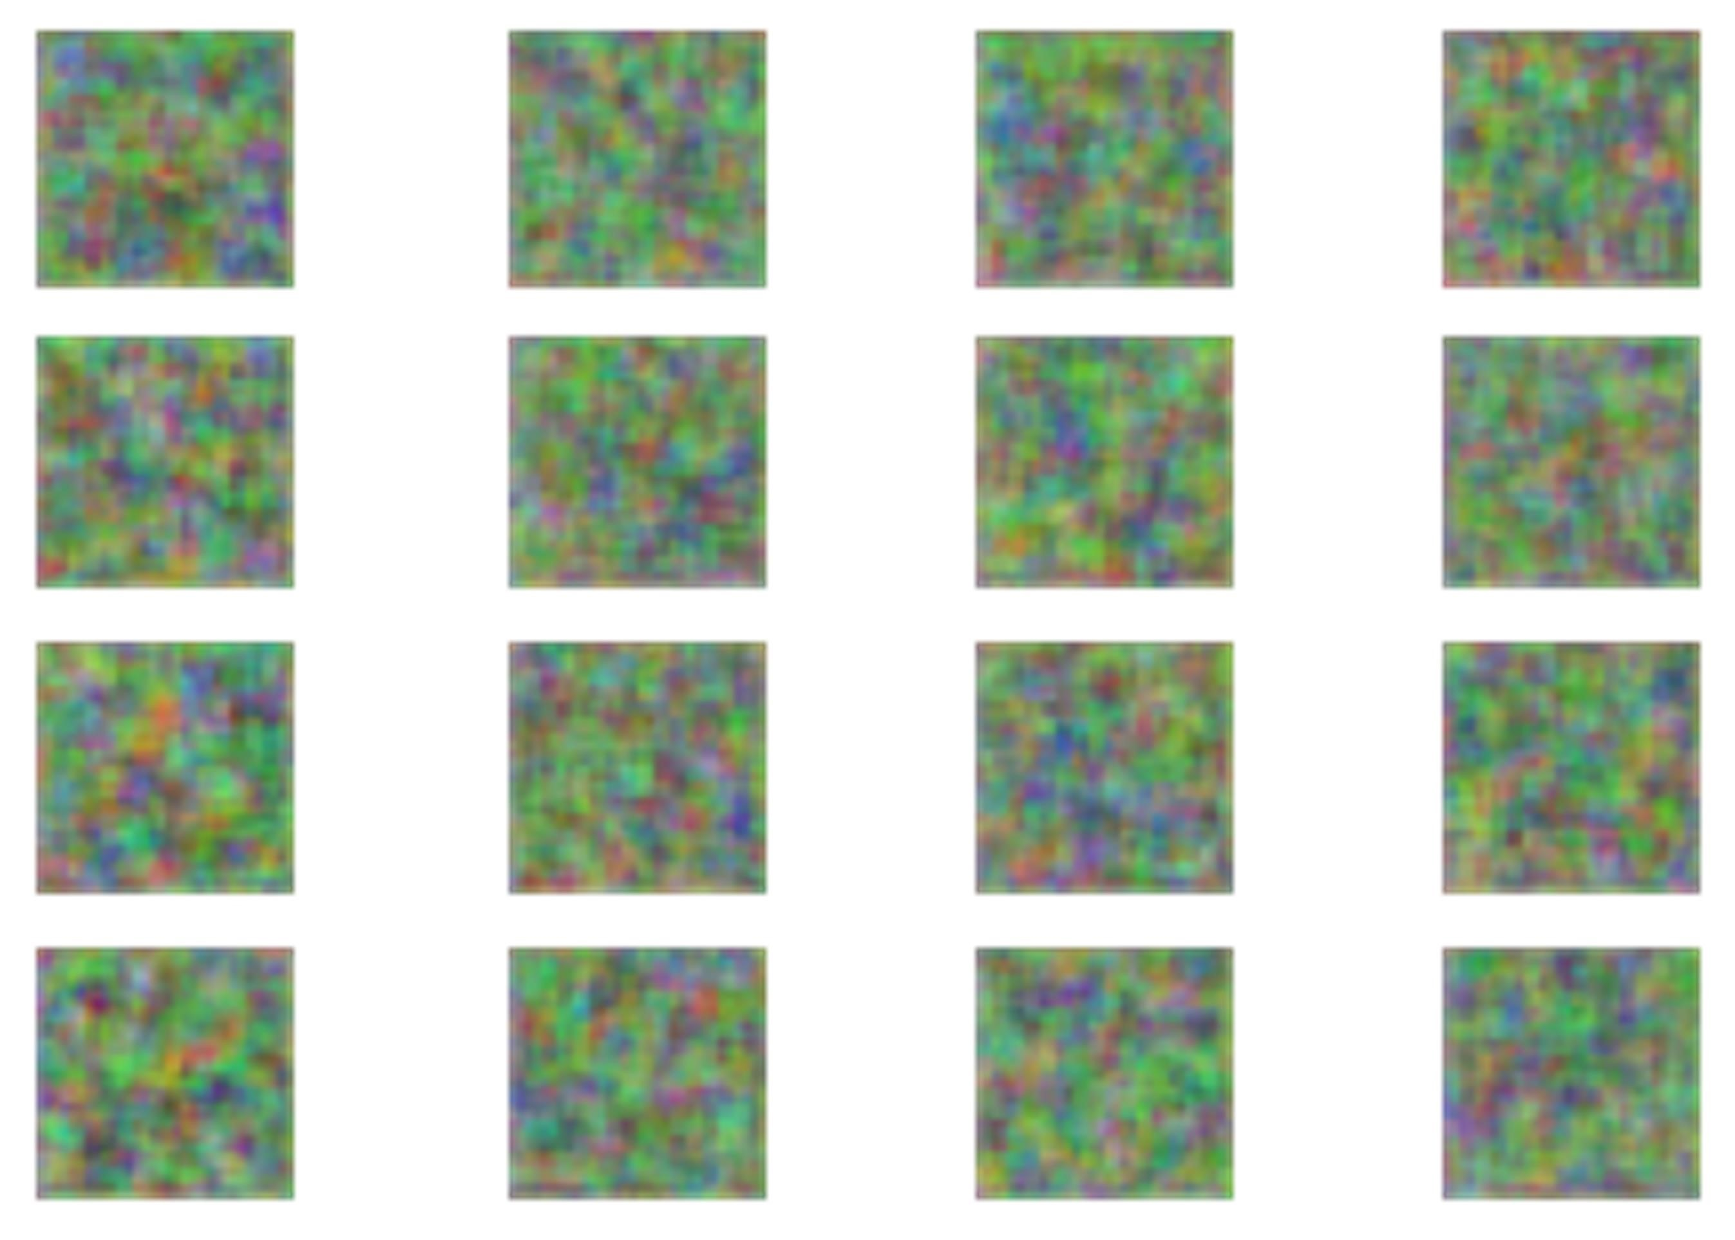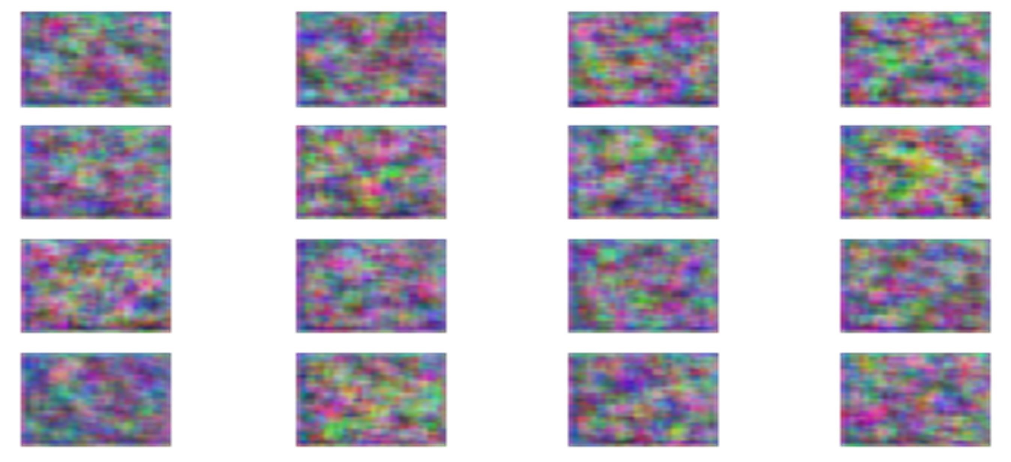

Program:

import m3u8 import requests

from bs4 import BeautifulSoup from tqdm import tqdm_notebook as tqdm import subprocess import requests chunk_size = 256 sess = requests.session()

ganna_url = "https://gaana.com/album/ek-love-ya-original-motionpicture-soundtrack" bob_ganna_url = "https://gaana.com/d0d959d9-fac9-4f38-ad6fa80fc09a468f" log_sing = "?sign=1646556464-Zi7mUDtXYR-0-32a0f29f4bf3977b05ade364f1cbe442" m3File1

="https://vodhlsgaana.akamaized.net/hls/72/4992872/39791107/96/hdntl=exp=1646643931~a cl=%2f*~data=hdntl~hmac=735cd0c11a600b98f7fd283dce25dfaab0f5c006e5fea07ef50cdcfd d525960b/index.m3u8" m3File = m3File1 + log_sing r = sess.get(m3File, stream=True) m3u8_master = m3u8.loads(r.text)

m3u8_master

playlist_uri = m3u8_master.data['segments']

main_url = "https://streamcdn.gaana.com/songs/67/5206667/40781248/40781248_96.mp4/"

# playlist_url = main_url + playlist_uri # r = requests.get(playlist_url) with open('soung1.ts', 'wb') as f:

for segment in playlist_uri:

uri = segment['uri'] url = main_url + uri r =requests.get(url) f.write(r.content)

subprocess.run(['ffmpeg', '-i','soung1.ts','soung.mp4'],shell=True)

Output:

